 | 30 Editors - Preferences
Table of content
Detailed Table of content 2
Preferences 12
Navigation Sidebar 12
Interface Tab 13
Display Panel 13
Editors Panel 15
Language Panel 16
Accessibility Panel 18
Text Rendering Panel 18
Menus Panel 19
Viewport 20
Display 20
Quality 21
Textures 22
Subdivisions 22
Lights 23
Studio Lights 23
MatCaps 24
LookDevHDRI's 24
Editing 25
Objects 25
3D Cursor 26
Annotations 26
Weight Paint 26
Grease Pencil 28
Text 28
Node Editor 28
Video Sequencer 29
Outliner 29
Miscellaneous 30
Animation 30
Timeline 30
Extensions 33
Search Extensions 33
Filter Extensions 34
Repositories 34
Repository List 34
Add 35
Remove 36
Remove Repository 36
Refresh Remote 36
Active Extension Repository 37
Check for Updates on Startup 37
Advanced Subpanel 37
Extensions Settings 38
Allow Online Access 39
Online Extensions 39
Repository Acccess Errors 40
Add-ons 40
Search field 40
Extension Tags 41
Refresh Local 41
List of Addons 41
Themes 42
Presets 42
Install 43
Reset 43
List of Editors 43
Input 45
Keyboard 45
Mouse 45
Tablet 46
Touchpad 46
NDOF 47
Navigation 48
Orbit & Pan 48
Zoom 49
Fly & Walk 49
Keymap 51
Header 51
Key map Editor 52
System 53
Cycles Render Devices 53
Display Graphics 54
Operating System Settings 54
Network 55
Memory and Limits 55
Video Sequencer 56
Sound 57
Save & Load 58
Blend Files 58
File Browser 60
File Paths 60
Data 60
Script Directories 61
Render 61
Applications 62
Development 62
Asset Libraries 62
Developer Tools 63
Experimental 64

Detailed Table of content

Detailed table of content
Detailed Table of content 2
Preferences 12
Navigation Sidebar 12
Save Preferences menu 12
Auto Save preferences 12
Save Preferences 12
Revert to Saved Preferences 12
Load Factory Preferences 12
Interface Tab 13
Display Panel 13
Resolution Scale 13
Line Width 13
Viewport Line Width 13
Splash Screen 14
Tool tips 14
Python Tool tips 14
Developer Extras 14
Sort Search by Most Recent 14
Show Hidden 14
Disable Search on Key Press 14
Disable Material Icon Rendering 14
Editors Panel 15
Region Overlap 15
Corner Handles 15
Numeric Input Arrows 15
Navigation Controls 15
Border Width 15
Color Picker Type 15
Header Position 16
Factor Display Type 16
Temporary Editors subpanel 16
Render in 16
File browser 16
Status Bar subpanel 16
Language Panel 16
Language 17
Translate 17
Tool tips 17
Interface 17
Reports 17
New Data 17
Accessibility Panel 18
Reduced Motion 18
Text Rendering Panel 18
Anti-Aliasing 18
Subpixel Anti-Aliasing 18
Hinting 18
Interface Font 19
Monospace Font 19
Menus Panel 19
Open on Mouse Over 19
Top Level 19
Sub Level 19
Pie Menus 19
Animation Timeout 19
Top Key Timeout 19
Recenter Timeout 19
Radius 19
Threshold 19
Confirm Threshold 19
Viewport 20
Display 20
Text Info Overlay 20
Object Info 20
View Name 20
Playback Frame Rate (FPS) 20
Frame Rate Samples 20
Gizmo Size 21
Reference Sphere Size 21
3D Viewport Axis 21
Off 21
Simple Axis 21
Size 21
Brightness 21
Interactive Navigation 21
Size 21
Fresnel in Edit Mode 21
Quality 21
Viewport Anti-Aliasing 21
Multi sampling 22
Grease Pencil Multi sampling 22
Edit Mode Smooth Wires 22
Textures 22
Limit Size 22
Anisotropic Filtering 22
Clip Alpha 22
Image Display Method 22
Subdivisions 22
GPU Subdivisions 22
Lights 23
Studio Lights 23
Install 23
Preview Window 23
Delete Studio Light 23
Copy Studio Light settings to the Studio Light Editor 23
Edit Studio Light 24
Save as Studio Light 24
Use Light 24
Diffuse 24
Specular 24
Smooth 24
Direction 24
MatCaps 24
LookDevHDRI's 24
Editing 25
Objects 25
New Objects 25
Link Materials To 25
ObData 25
Object 25
Align To 25
World 25
View 26
Enter Edit Mode 26
Instance Empty Size 26
Copy on Duplicate Data subtab 26
3D Cursor 26
Surface Project 26
Lock Adjust 26
Annotations 26
Default Color 26
Eraser radius 26
Weight Paint 26
Use Custom Colors 27
Tools Menu 27
Background Color 28
Gradient Stroke Mode 28
Grease Pencil 28
Manhattan Distance 28
Euclidean Distance 28
Text 28
Auto-close Character Pairs 28
Node Editor 28
Auto Offset 28
Auto Offset Margin 29
Preview Resolution 29
Auto position Viewer Node 29
Node Color Blend 29
Video Sequencer 29
Connect Movie Strips by Default 29
Outliner 29
Colored Collection Rows 29
Miscellaneous 30
Sculpt Overlay Color 30
Animation 30
Timeline 30
Allow negative Frames 30
Minimum Grid Spacing 30
Time Code Style 31
Zoom To Frame Type 31
Keyframes 31
Default Key channels 31
Visual Keying 31
Only Insert Needed 31
Auto Keyframing subpanel 31
Show Warning 31
Only Insert Available 31
Enable in new scenes 31
F-Curves 32
Unselected Opacity 32
Default Smoothing Mode 32
Default Interpolation 32
Default Handles 32
XYZ to RGB 32
Channel Group Colors 32
Only Show Selected F-Curve Keyframes 32
F-Curve High Quality Drawing 32
Extensions 33
Search Extensions 33
Filter Extensions 34
Filter Extensions Settings Dropdown 34
Dropdown – Repository Filter 34
Show Tags 34
Tag List (Checkboxes) 34
Repositories 34
Repository List 34
Enable 34
URL field 35
Add 35
Add Remote Repository 35
Add New Extension Repository dialog 35
URL 35
Check for Updates on Startup 35
Authentification 35
Requires Access Token 35
Secret 35
Custom Directory 35
Custom Directory 35
Create 35
Cancel 36
Add Local Repository 36
Name 36
Use Custom Directory 36
Custom Directory 36
Create 36
Cancel 36
Remove 36
Remove Repository 36
Remove Repository & Files 36
Refresh Remote 36
Active Extension Repository 37
Install Available Updates 37
Force Unlock Repository 37
Check for Updates on Startup 37
Advanced Subpanel 37
Custom Directory 37
Directory 38
Browse 38
Source 38
Authentification 38
Requires Access Token 38
Secret 38
Module 38
Extensions Settings 38
Visit extensions website 38
Install Available Updates 38
Refresh Remote 38
Install from Disk 38
Refresh Local 38
Enable Built-in Legacy Add-ons 39
Allow Online Access 39
Online Extensions 39
Continue Offline 39
Allow Online Access 39
Repository Acccess Errors 40
Enable/Remove Built-in Legacy Add-ons 40
Install Pre-downlaoded Extensions Equivalents 40
Add-ons 40
Drag and Drop 40
Search field 40
Enabled only 40
Install from Disk 41
Extension Tags 41
Refresh Local 41
List of Addons 41
Themes 42
Presets 42
Create new Theme 42
Remove Theme 42
Save Theme 43
Install 43
Reset 43
List of Editors 43
User Interface 43
Text Style 43
Bone Color Sets 43
Collection Colors 43
Strip Color Tags 43
Regions 43
Common 43
Asset Shelf 44
3D Viewport 44
Dope Sheet / Timeline 44
File / Asset Browser 44
Graph Editor / Drivers 44
Image / UV Editor 44
Info 44
Movie Clip Editor 44
Node Editor 44
Nonlinear Animation 44
Outliner 44
Preferences 44
Properties 45
Spreadsheet 45
Text Editor 45
Top Bar 45
Video Sequencer 45
Input 45
Keyboard 45
Emulate Numpad 45
Default to advanced numeric input 45
Mouse 45
Emulate 3 Button Mouse 45
Tablet 46
Tablet API 46
Max Threshold 46
Softness 46
Touchpad 46
Multi Touch Gestures 46
NDOF 47
Pan Sensitivity 47
Orbit Sensitivity 47
Deadzone 47
Navigation 47
Rotation 47
Show Navigation Guide 47
Invert Zoom 47
Lock Camera Pan/Zoom 47
Pan Swap Y and X Axes 47
Invert Axis Pan 47
Orbit 47
Fly / Walk 47
Lock Horizon 47
Helicopter Mode 48
Navigation 48
Orbit & Pan 48
Orbit Method 48
Orbit around selection 48
Auto Perspective 48
Auto Depth 48
Smooth View 48
Rotation Angle 48
Zoom 49
Zoom Method 49
Continue 49
Dolly 49
Scale 49
Zoom Axis 49
Invert Mouse Zoom Direction 49
Invert Wheel Zoom Direction 49
Zoom to Mouse Position 49
Fly & Walk 49
View Navigation 50
Walk 50
Reverse Mouse 50
Horizontal Lock 50
Mouse Sensitivity 50
Teleport Duration 50
Walk Speed 50
Speed Factor 50
Gravity 50
View Height 50
Jump Height 51
Fly 51
Keymap 51
Header 51
Key Configs 51
Import 51
Export 51
Filter Type 51
Search Field 51
Key map Editor 52
Map Type 52
Type of Event 52
Operator 52
Type of Event 52
Value 52
Secondary hotkeys 52
Specific settings 53
Restore 53
System 53
Cycles Render Devices 53
None 53
CUDA 53
OptiX 54
HIP 54
OneAPI 54
Metal (Mac-OS only) 54
Display Graphics 54
Backend 54
OpenGL 54
Vulkan (Experimental) 54
Operating System Settings 54
For all Users 54
Make default 54
Network 55
Allow Online Access 55
Time Out 55
Connection Limit 55
Memory and Limits 55
Undo Steps 55
Undo Memory Limit 55
Global Undo 55
Console Scrollback Lines 55
Texture Time Out 55
Garbage Collection Rate 55
VBO Time Out 56
Garbage Collection Rate 56
Video Sequencer 56
Memory Cache Limit 56
Use Disk Cache 56
Directory 56
Cache Limit 56
Compression 56
Proxy Setup 56
Automatic 56
Manual 56
Sound 57
Audio Device 57
OpenAL 57
OpenAL - OpenAL Soft 57
SDL 57
Null 57
Channels 57
Mixing Buffer 57
Sample Rate 57
Sample Format 58
Save & Load 58
Blend Files 58
Relative Paths 58
Compress File 58
Load UI 58
File Preview 58
None 58
Auto 58
Screenshot 59
Camera Preview 59
Tabs as Spaces 59
Save Prompt 59
Save Versions 59
Recent Files 59
Auto Save 59
Auto Save Temporary File 59
Timer 59
Auto Run Python Scripts 59
Excluded paths 60
File Browser 60
Filter Files 60
Show Hidden File/Data 60
Show Recent Locations 60
Show System Bookmarks 60
File Paths 60
Data 60
Fonts 60
Textures 60
Sounds 61
Temporary Files 61
Script Directories 61
Render 61
Render Output 61
Render Cache 61
Applications 62
Image Editor 62
Animation Player 62
Text Editor 62
Program 62
Arguments 62
Development 62
I18n Branches 62
Asset Libraries 62
Asset List 62
Add 63
Remove 63
Move Up/Down 63
Path 63
Import Method 63
Append (Reuse Data) 63
Append 63
Link 63
Relative Path 63
Developer Tools 63
Experimental 64

Preferences
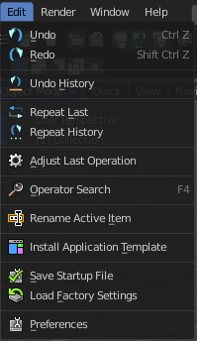
The Preferences is the place where you can tweak several settings to your needs. It can be opened in the Edit menu in the top bar.
The Preferences contains several tabs. And every tab contains several rows or panels with content. We will go through them one by one.
When you have changed something, and want that changes to be permanent, then you are required to save the user settings. See the Save User Settings button in the header.

Navigation Sidebar
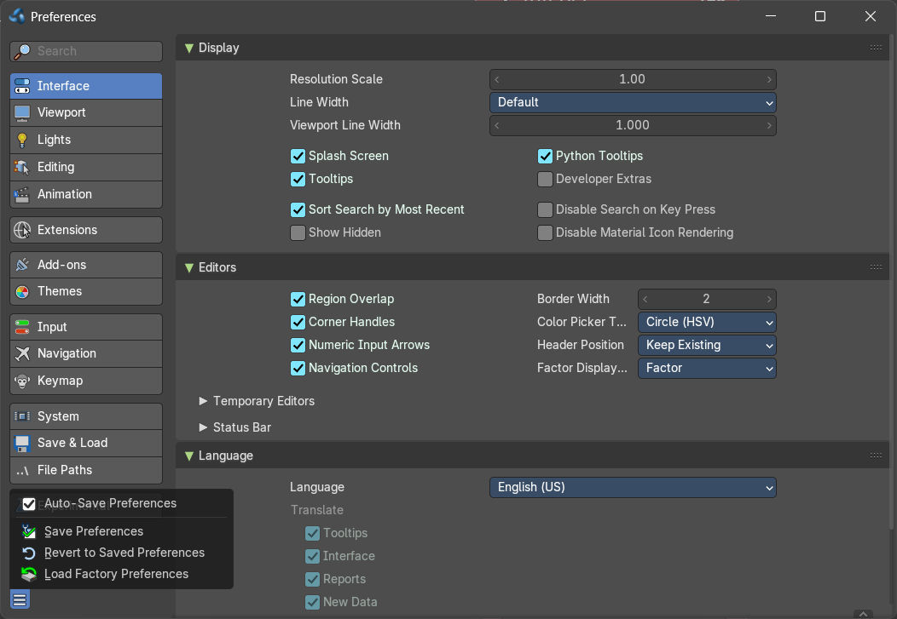
At the left side you will find the navigation elements to access the different categories. Including a search bar where you can search for specific items.
At the bottom resides the Save Preferences menu.

Save Preferences menu

Auto Save preferences
Changes at the preferences are saved automatically when Auto Save Preferences is ticked. When this option is off, then changes needs to be saved manually. When you don't save the changes, then Bforartists loads the next time with the status before the changes.
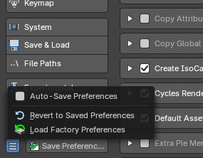
Note that when Auto Save Preferecnes is unticked, then the Save Preferences button is displayed in the sidebar besides the Save Preferences menu, and not longer in the Save Preferences menu.

Save Preferences
Manually saves the current state.

Revert to Saved Preferences
This option is just available when Auto Save preferences is off. It reverts the settings to the last saved state.

Load Factory Preferences
Resets the settings to the factory defaults.

Note
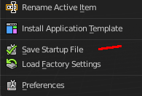
Not everything can be changed from the Preferences. Everything regarding layout is stored in the Startup File, and not in the Preferences. So when you want to save a layout change then you have to save the startup file. The menu item is right above the Preferences button in the Edit menu.

Interface Tab

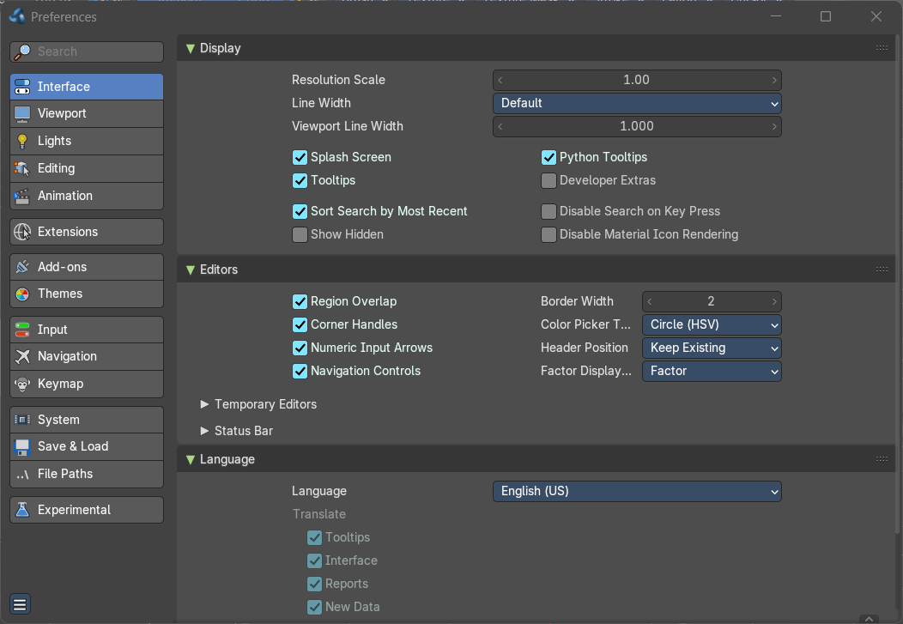
The Interface category contains settings to change how UI elements are displayed and how they react.

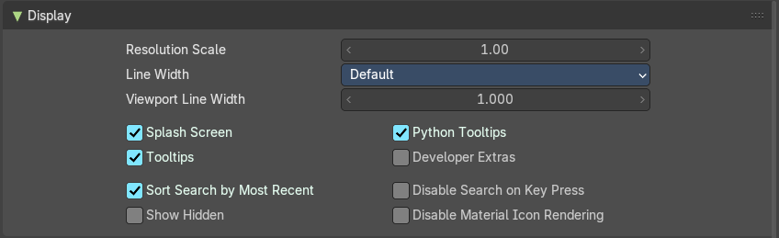
Display Panel

Resolution Scale
At 4K displays the whole UI elements are usually ways too small. Scale the whole UI size display by moving the slider to the needed value.

Line Width
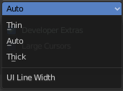
Define the size of the line between the editors. This is a theming setting.

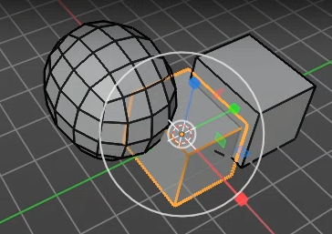
Viewport Line Width
Changes the appearance of only lines in the 3D Viewport.

Splash Screen
Display the Splash Screen when starting Bforartists.

Tool tips
Display tool tips in the UI. With this feature unticked you won't see any tool tips anymore. It is not recommended to turn this feature off. The icon buttons needs the tool tips to display the tool name.

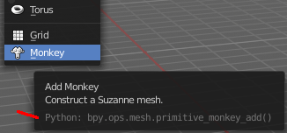
Python Tool tips
Every tool tip can also display the Python code tag for the tool. It may look like noise in the first moment. But can give you some further hints here and there. Some tool tips, like the Node editor buttons, doesn't have a proper tool description by design. Here the Python tool tip can tell you the function when you turn it into pure icon buttons.
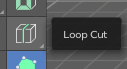
The tools in the tool shelf doesn't have a Python tool tip by design. This buttons sits on top of the normal operators, and doesn't access the tool tip of it.
Note: It is not recommended to turn the Python tool tips off.

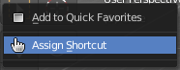
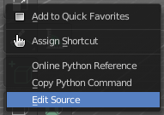
Developer Extras
This tick box turns on or off the developer entries in the right click menus.

Sort Search by Most Recent
This affects all search fields. Sort the recently searched items at the top.

Show Hidden
Show hidden data that are hidden away with a dot before the name in search menus.

Disable Search on Key Press
Ignore menus toggling with Search on Key Press, and fallback to using accelerator keys instead. This is a Bforartists only feature.

Disable Material Icon Rendering
Stops the preview icons on the material properties from rendering, which helps avoid causing the UI to stutter or freeze. This is a Bforartists only feature.

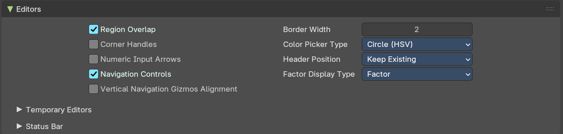
Editors Panel

Region Overlap
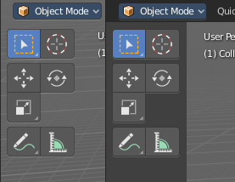
This checkbox will enable Blender to draw the Header, Tool Shelf and the Sidebar overlapping the 3D View. The transparent areas becomes workspace area. You can for example select vertices now in the transparent areas.
If you have a capable graphics card and drivers with Triple Buffer support, clicking the checkbox will enable the overlapping regions to be drawn using the Triple Buffer method, which will also enable them to be drawn using Alpha, showing the 3D View contents trough the Object Tools and Transform Properties regions.

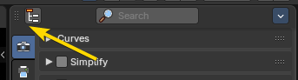
Corner Handles
Displays small clickable handles in the corners of editor regions. Makes it easier to resize or split editors by dragging from the corners, especially in dense layouts. mproves discoverability and precision for users who prefer visual cues over edge-hovering in the editors.

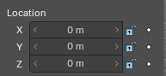
Numeric Input Arrows
Adds left/right arrow buttons beside numeric fields. Lets you increment or decrement values by clicking, rather than typing or dragging. Offers a more tactile, UI-friendly way to adjust numbers—especially useful for tablets, styluses, or keyboard-free setups.

Navigation Controls
Show the navigation controls in the 2d and 3d views

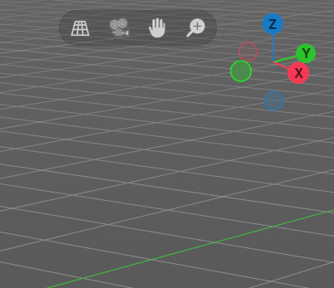
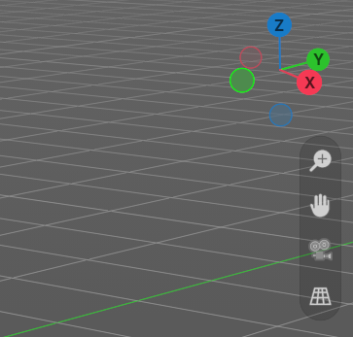
Vertical Navigation Gizmos Alignment
Revert Navigation Controls to be vertical instead of Bforartists default horizontal alignment. Default is off.

Border Width
Size of the padding around each editor.

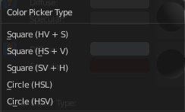
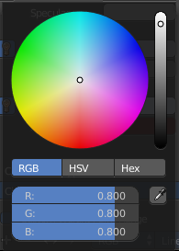
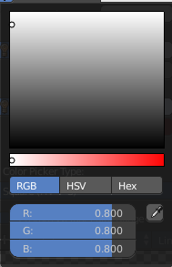
Color Picker Type
Choose the type of Color picker that will show when you click on a color field. You can choose between three square types and two circle types.

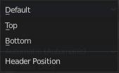
Header Position
Define at which default position the headers of the editors should reside.

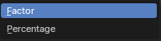
Factor Display Type
Display factor values either as percentage or as factor.

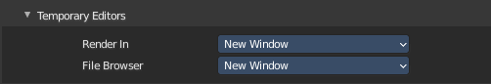
Temporary Editors subpanel
How the temporary editors behave.

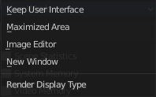
Render in
Where to display the rendered image.

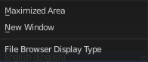
File browser
Where to open the file browser.

Status Bar subpanel
These checkboxes let you customize what info appears in the status bar at the footer of the main window. The list is explicit.
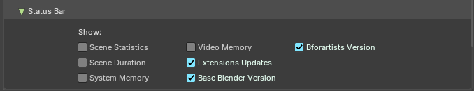

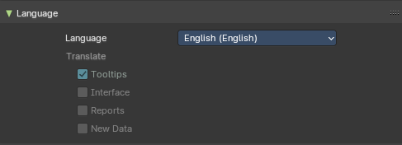
Language Panel
Choose another default language for Bforartists.

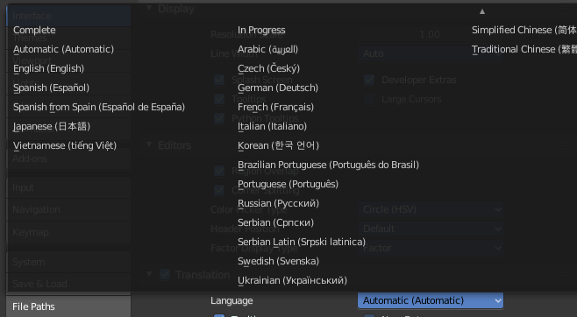
Language
Choose between automatic language detection. In this case the system language gets chosen. Or pick a language that you want to use.

Translate

Tool tips
Tool tips translates the tool tips too.

Interface
Interface translates all the interface texts.

Reports
Translate report and error messages too.

New Data
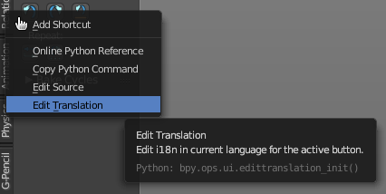
New data is meant to edit the localization texts.
This can be done in the right click menus of the tools when everything is set up in the correct way.
This is a development feature. You need a repository of Bforartists!

Note
This feature is currently not functional in Bforartists. It ends in an error message.

Let's nevertheless document the way how it should work. Note that you need a Bforartists repository for that. The binary version does not come with the editable *.po files, but with already compiled *.mo files for the translation.
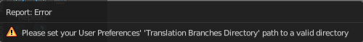
Note that you first need to set the path to the translation files for that. Or you will get an error. This is done in the File tab. The |18n string.
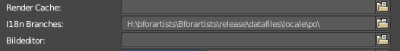
The path should lead to the *.po files that you want to translate. Which can be found in the Bforartists repository.
And you need to enable the Manage UI translations add-on. And to fix the paths in this add-on. The default paths are currently set for Blender.
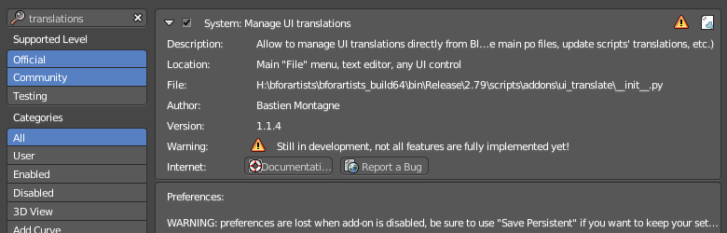

And then you might end in this error here ...
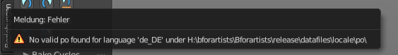

In case somebody has an idea what's going on here, every hint is welcome …

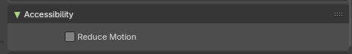
Accessibility Panel

Reduced Motion
The Reduce Motion option is designed to improve usability for users sensitive to motion effects. When enabled, the interface minimizes or disables non-essential animations in the interface.

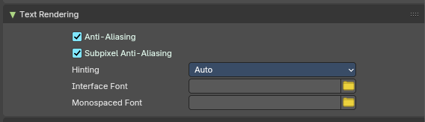
Text Rendering Panel
Text related settings for the font of the interface.

Anti-Aliasing
Use Anti Alias at the UI elements to prevent pixelated look of the font.

Subpixel Anti-Aliasing
Use subpixel calculations to refine the horizontal spacing between characters.

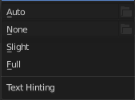
Hinting
What sharpening method to use to make the text render sharp.

Interface Font
Define a custom interface font. The font in the whole UI.

Monospace Font
Define a custom Monospace font. That's the one used in the python console for example.

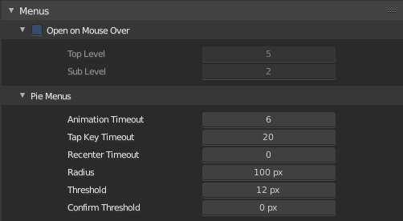
Menus Panel

Open on Mouse Over
Normally you click at a menu to open it. With Open on Mouse Over the menu opens up when you just hover with the mouse over it.

Top Level
Adjust the time delay before the top level menu opens on mouse over.

Sub Level
Adjust the time delay before a sub level menu opens on mouse over.

Pie Menus
Bforartists has some pie menus that can be called by hotkeys. Here you find some settings for it.

Animation Timeout
The pie menu fades in with an animation. Adjust the time needed to fully unfold the pie menu.

Top Key Timeout
Pie menu button longer held than this time will dismiss the menu on release.

Recenter Timeout
Pie menus will use the initial mouse position as center for this amount of time. The value is in 1/100 seconds.

Radius
The pie menu size in pixels.

Threshold
The distance that is needed from the center to move the mouse so that a selection can be made.

Confirm Threshold
Distance threshold after which selection is made. A value of zero disables this feature.

Viewport

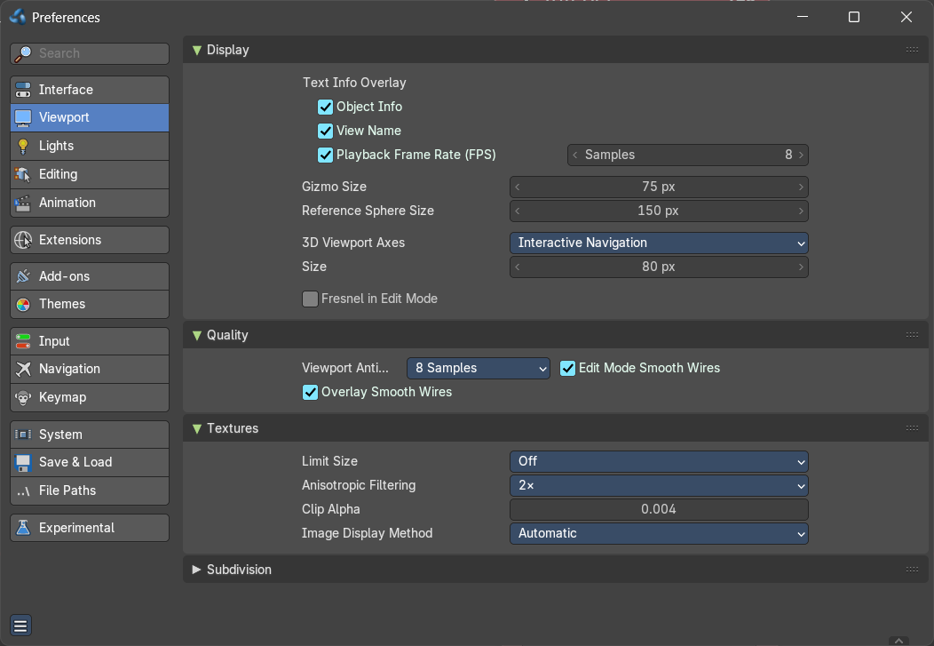
Contains the settings for the 3D Viewport.

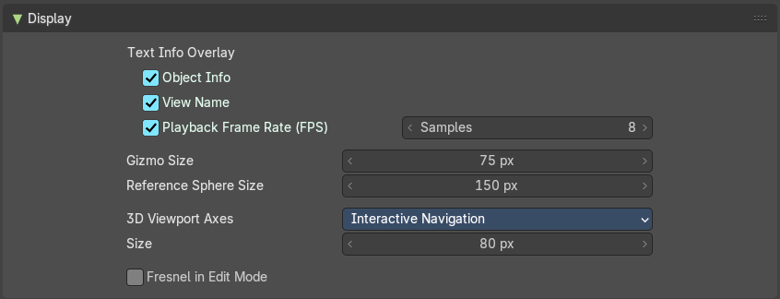
Display

Text Info Overlay

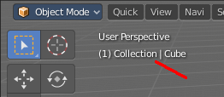
Object Info
Display current frame, collection name and Object name in the upper left edge of the 3D view.
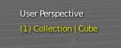
The letters appears in yellow when the current frame of the selected object has a keyframe.

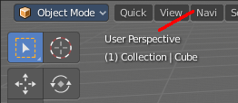
View Name
Display the name of the current view up left in the 3D view.

Playback Frame Rate (FPS)
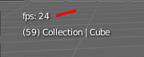
Show the frames per second screen refresh rate while an animation is played back. It appears in the viewport corner, displaying red if the frame rate set cannot be reached. And replaces the View name while the animation is playing.

Frame Rate Samples
The number of frames to use for calculating the fps average. A value of zero calculates the fps automatically, where the nunber of samples matches the target fps.

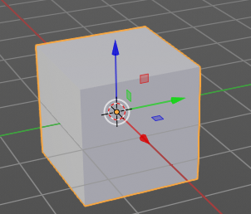
Gizmo Size
Adjust the size of the transform gizmo that appears when you have one of the transform tools activated.

Reference Sphere Size
How big the preview spheres are displayed.

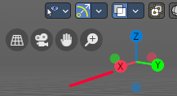
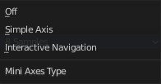
3D Viewport Axis
Adjust the apperance of the 3D Viewport mini axis widget.

Off
Hides the Mini axis widget

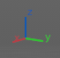
Simple Axis
Shows simple axis. This widget type is not interactive. It just shows the state of the viewport rotation.

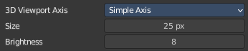
Size
The size of the simple mini axis widget.

Brightness
The brighness of th simple mini axis widget.

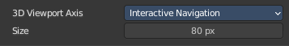
Interactive Navigation
The default mini axis widget. This widget is interactive. Clicking and dragging will rotate the viewport. Clicking at one of the colored spots at the end of the axis will snap to the neares orthographic view.

Size
The size of the interactive navigation widget.

Fresnel in Edit Mode
Enable a fresnel effect on edit mesh overlays. This feature improves shape readability of very dense meshes. But can increase eye fatigue when modeling lower poly.

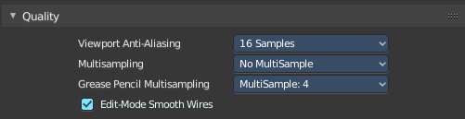
Quality
Contains the settings to adjust the display quality in the viewport.

Viewport Anti-Aliasing
The anti alias quality settings for the solid mode rendering in the 3d viewport.

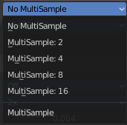
Multi sampling
Set the OpenGL Multi sampling in case your system supports it.

Grease Pencil Multi sampling
The grease pencil drawing has its own OpenGL Multi sampling. Set the OpenGL Multi sampling in case your system supports it.

Edit Mode Smooth Wires
Enable Edit Mode edge smoothing which reduces anti alias and makes the edge more sharp. A change requires a restart of the software.

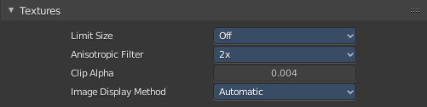
Textures

Limit Size
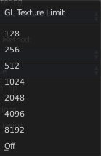
Limit the maximum resolution for pictures used in textured display to save memory. The limit options are specified in a square of pixels, (e.g.: the option 256 means a texture of 256×256 pixels) This is useful for game engineers, whereas the texture limit matches paging blocks of the textures in the target graphic card memory. Available Options are: Off (No limit), 128, 256, 512, 1024, 2048, 4096, and 8192.

Anisotropic Filtering
Sets the level of anisotropic filtering. This improves the quality of how textures are drawn at the cost of performance. Available Options are: Off (No Filtering), 2x, 4x, 8x, and 16x.

Clip Alpha
Clip alpha when the value is below the here defined value.

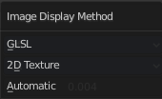
Image Display Method
The method that is used to draw textures in the viewport.

Subdivisions

GPU Subdivisions
Enable GPU acceleration for evaluating the last subdivision surface modifier at the bottom of the modifier stack. This greatly improves subdivision performance on playback and evaluation.

Lights
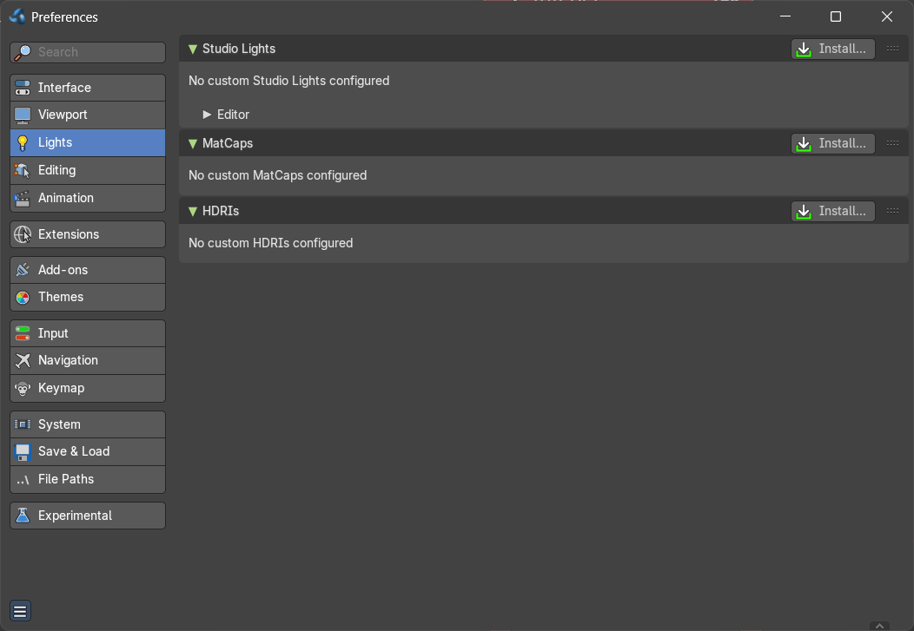
The viewport uses different light setups in different situations. You can switch between them in the shading drop down in the 3d view up right.

This tab allows you to customize these light setups. And install custom light setups.

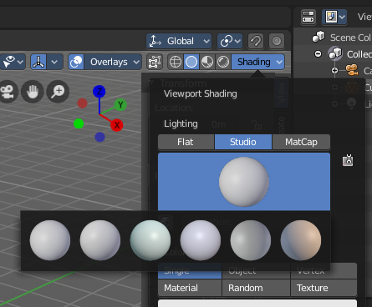
Studio Lights
The 3D view uses Solid OpenGL lamps to light the 3D view. You can enable four different light sources here. These lamps does not affect the rendering. Their only purpose is to light the 3D view.
You can turn on or off the lamps. But there should be at least one light enabled.

Install
Install an external studio light.

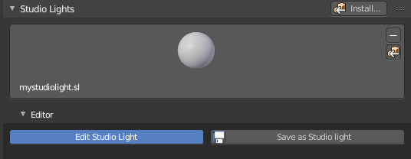
Preview Window
This window appears when you have a studio light saved, or a new studio light installed.
Down left you can see the name of the saved library. mystudio.sl .
This window gives you a preview of how this studio light looks like in the 3D view then.
Up right you can find two buttons.

Delete Studio Light
Deletes the studio light.

Copy Studio Light settings to the Studio Light Editor
The editor settings does not update immediately. It shows the default studio light setting. So when you want to edit the studio light, then you want to press this button to update the editor values first.

Edit Studio Light
Enable the editing of the studio light setup.

Save as Studio Light
Save the current light setup as a studio light setup. Note that this does not export the light, but saves its settings internally in the appdata directory.

Use Light
Turn on or off this specific light.

Diffuse
Diffuse color is the constant color of the lamp.

Specular
Specular is the highlight color of the lamp.

Smooth
Smooth the lighting from this specific light.

Direction
Adjust the direction. Click into the field and drag the sphere around until you have your desired light setup.

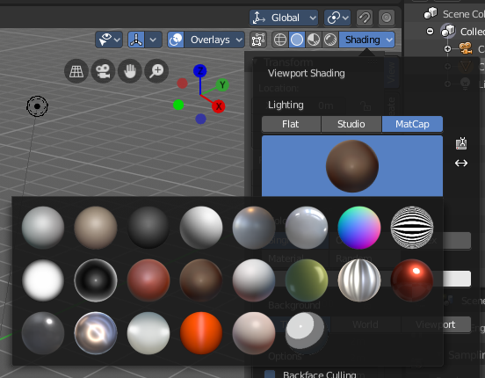
MatCaps
Matcaps is a special material that can be assigned quickly to preview geometry. Usually matcaps are used while sculpting. You can switch between them in the shading drop down in the 3d view up right.
Install and manage custom matcaps.

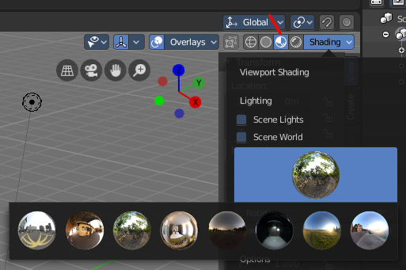
LookDevHDRI's
You can light the scene with an environment image instead of lights. This is done with hdri images.
The viewport can do this in realtime when the shading is set to Viewport Shading.
Install and manage custom LookDev HDRI's. Basically every image could do the trick here. But the hdri's uses a special spherical mapping. So you better use hdri images for this purpose.
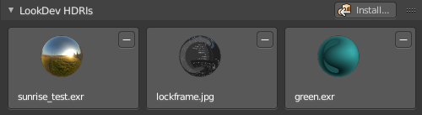

Editing

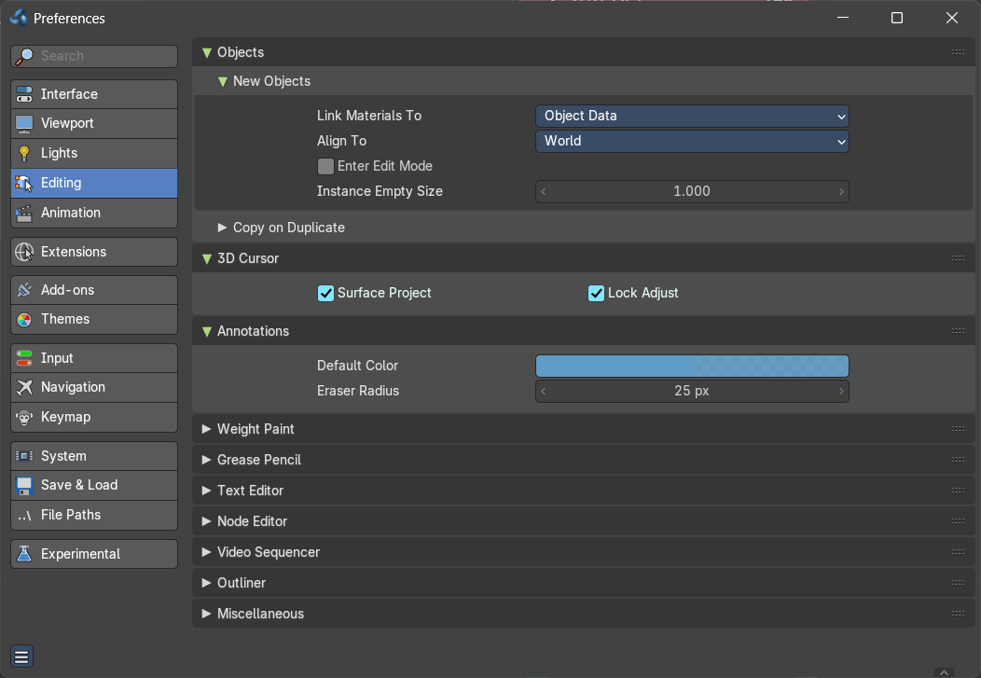
Contains the settings around editing. Objects, Data, etc.

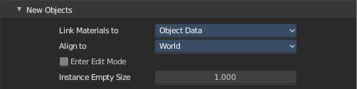
Objects

New Objects

Link Materials To
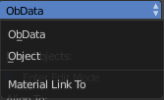
Define how materials will be linked to its objects. Almost everything in Bforartists is organized in a hierarchy of data-blocks. A data-block can be thought of as containers for certain pieces of information. For example, the Object data-block contains information about the Object’s location while the Object Data ObData data-block contains information about the mesh.

ObData
Any created material will be created as part of the ObData data-block.

Object
Any created material will be created as part of the Object data-block.

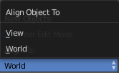
Align To

World
New objects align with world coordinates.

View
New object align with view coordinates.

Enter Edit Mode
If selected, Edit Mode is automatically activated when you create a new object.

Instance Empty Size
Increase or decrease the size of collection empties.

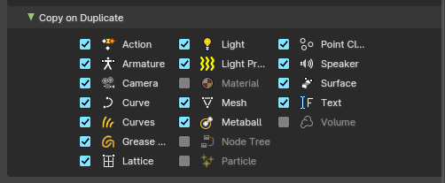
Copy on Duplicate Data subtab
When you duplicate data, then most or all its subpart gets duplicated too. Define which supports should be duplicated when you duplicate an object.

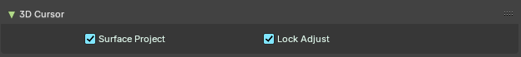
3D Cursor

Surface Project
Use the surface depth to place the 3D cursor. That way you can place the 3D cursor at the surface of an object.

Lock Adjust
Place the cursor without a jumping effect at the new location when lock to cursor is used.

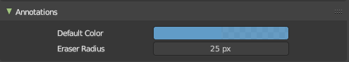
Annotations

Default Color
The default color for the annotations pencil.

Eraser radius
The eraser radius.

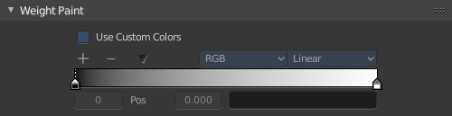
Weight Paint

Use Custom Colors
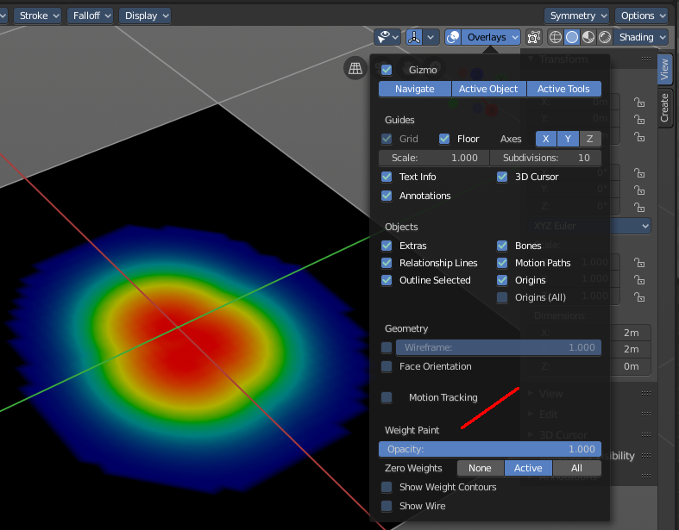
Bforartists uses by default a gradient that goes from red to green to blue to black to display the different weight at a mesh.
Setup a custom gradient for the colors of a weight paint.

The + Button adds a color stop point, which can be moved around. That way you can have more than one color in the gradient.

The - Button removes the currently selected color stop point.


Tools Menu
Flip Color ramp flips the color ramp.
Distribute Stops from Left distributes the color stops from the left. The position at the right will remain empty.
Distribute Stops evenly distributes the color stops evenly across the gradient.
Eyedropper allows you to pick a color from the gradient.
Reset color ramp resets the color ramp to the default state.

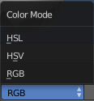
Color Mode is a drop down box to choose the color mode for the gradient.

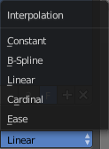
Interpolation is a drop down box to choose the interpolation mode for the gradient.

In the Color Ramp element you will see the color ramp with the single color stops.
Choose Active Color Stop is the stop point of the gradient.
Position is an edit box where you can numerically fine tune the position of the currently selected color stop.
Color Ramp Element displays the color of the current selected color stop. When you click at it then you can open a color picker to change the color of the current color stop.

Background Color
Background color is the same color than the secondary color from the color picker. When you click at it then you can open a color picker to change the secondary color.

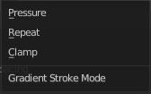
Gradient Stroke Mode
Set the gradient stroke mode.

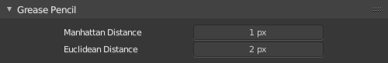
Grease Pencil

Manhattan Distance
The minimum number of pixels the mouse has to move horizontally or vertically before the movement is recorded.

Euclidean Distance
The minimum distance that mouse has to travel before movement is recorded.

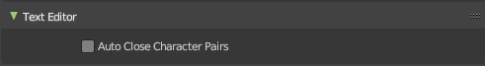
Text

Auto-close Character Pairs
Automatically close relevant character pairs when typing in the text editor.

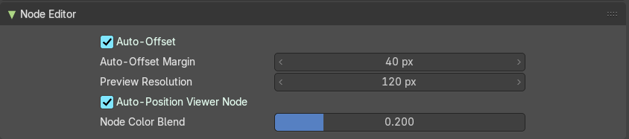
Node Editor

Auto Offset
Use Auto Offset.

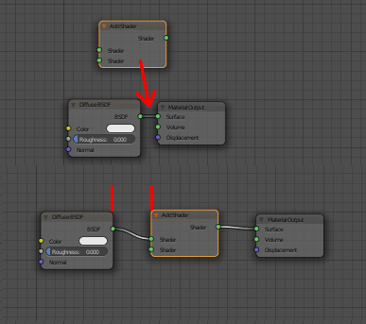
Auto Offset Margin
Minimum distance in the node editor between nodes for auto offsetting.
When you insert a new node between two existing connected nodes, then the two nodes gets pushed to left and right, with an offset. Adjust this offset.

Preview Resolution
Resolution used for shader node previews, which are displayed above the nodes.

Auto position Viewer Node
Automatically reposition the Viewer node near the selected socket when viewing data.

Node Color Blend
Bforartists blends node type color to its body, disable if the color is enabled.

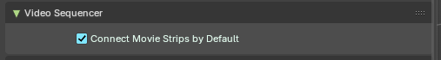
Video Sequencer

Connect Movie Strips by Default
Connect new Movie Strips by Default if they have multiple channels.

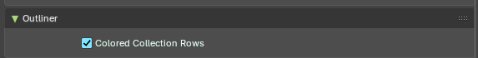
Outliner

Colored Collection Rows
Displays collections in the outliner with a colored line and background. You need to give the collection a color first in the right click menu to show this colored line.
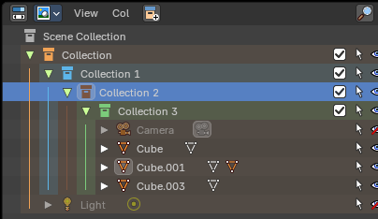

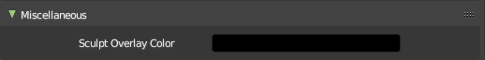
Miscellaneous

Sculpt Overlay Color
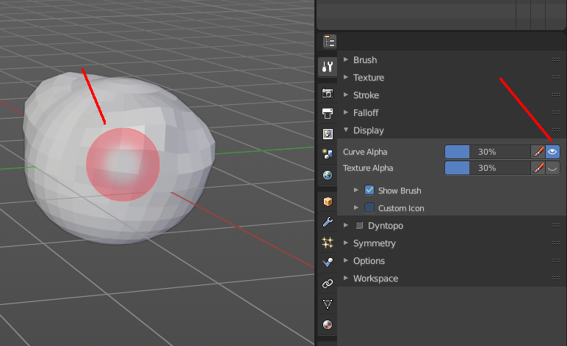
This color button allows the user to define a color to be used in the inner part of the brushes circle when in sculpt mode, and it is placed as an overlay to the brush, representing the focal point of the brush influence.
The overlay color is visible only when the overlay visibility is selected (clicking at the eye to set its visibility), and the transparency of the overlay is controlled by the alpha slider located at the brush pop-up, located at the top of the tool shelf, when in sculpt mode.

Animation

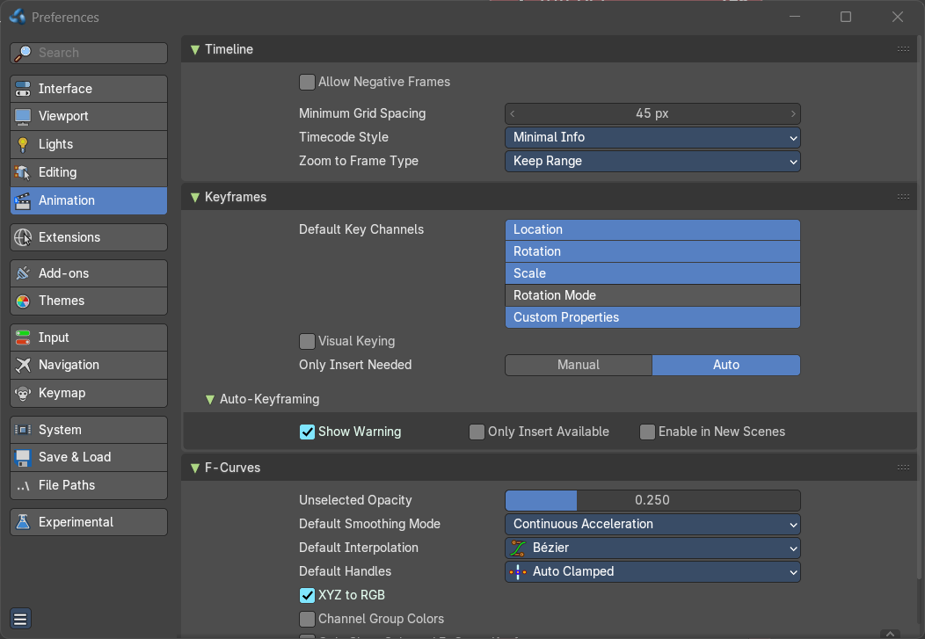
Contains the settings for the animation editors.

Timeline

Allow negative Frames

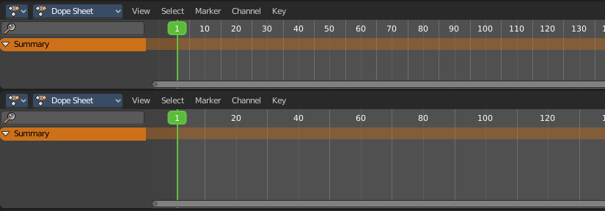
Minimum Grid Spacing
Adjust the minimum number of pixels between grid lines in a 2D viewport. This affects for example Timeline, Dope sheet, Graph or NLE Editor.

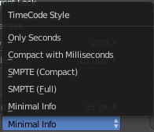
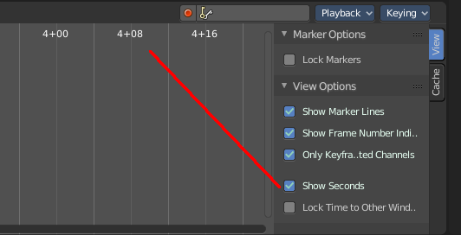
Time Code Style
In Timeline, Dope sheet, Graph and NLE editor you can either display the keyframe number or the time in the timeline. Define how the time gets displayed when you have chosen to display time.

Zoom To Frame Type
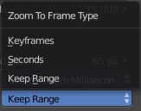
Timeline, Dope sheet, Graph and NLE. Define how zooming to frame focuses around current frame.

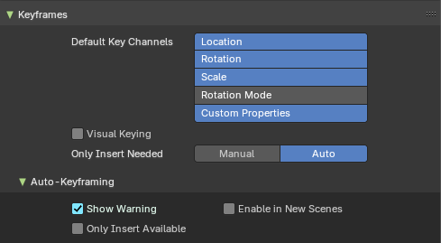
Keyframes

Default Key channels
Define which channels are recorded by default In case no keyingset is defined.

Visual Keying
When an object is using constraints, the objects property value doesn't actually change. Visual Keying will add keyframes to the object property, with a value based on the visual transformation from the constraint.

Only Insert Needed
With Auto it will only insert keyframes if the value of the property is different.
If there is a keyframe on the current frame, and it has no changes, it will skip recording over the keyframe.
If there is no keyframe, and it has no changes, skip recording the keyframe.

Auto Keyframing subpanel

Show Warning
Displays a warning at the top right of the 3D View, when moving objects, if Auto Keyframe is on.

Only Insert Available
This will only add keyframes to channel F-Curves that already exist.

Enable in new scenes
Automatic keyframe insertion for objects and bones as Default setting for new scenes.

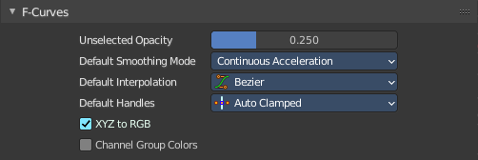
F-Curves

Unselected Opacity
The amount that unselected F-curves stands out from the background in the Graph Editor.

Default Smoothing Mode
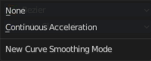
Auto handle smoothing mode for new added curves. None or Continuous accelleration.

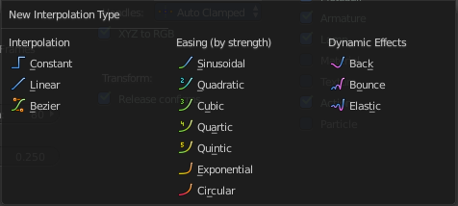
Default Interpolation
This controls how the state between two keyframes is computed. Default interpolation for new keyframes is Bezier which provides smooth acceleration and de-acceleration whereas Linear or Constant is more abrupt.

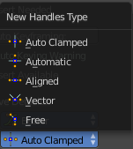
Default Handles
The default handle types for F-Curves.

XYZ to RGB
Color for X, Y or Z animation curves (location, scale or rotation) are the same as the color for the X, Y and Z axis.

Channel Group Colors
Use animation channel group colors. Uses the bone group colors.

Only Show Selected F-Curve Keyframes
Just show the keyframes from the selected curves only.

F-Curve High Quality Drawing
Display the curves in highest quality.

Extensions

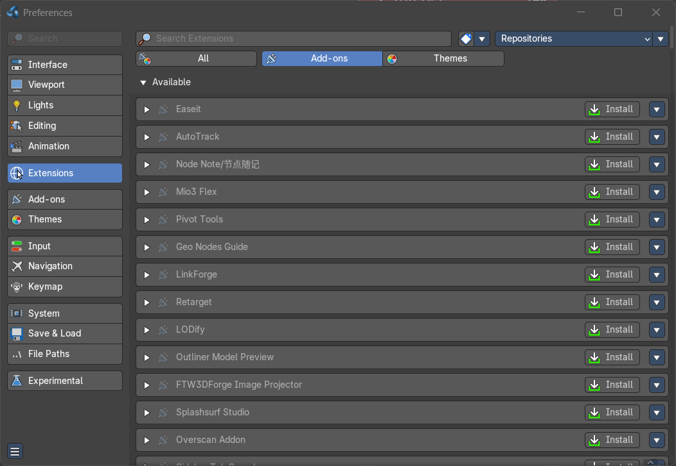
In this section you can manage the availability of online add-ons and themes. Blender has an online repository with it. And you can download the ones that you need.
A theme allows you to customize the colors of the user interface. An extension add-on is external software written by other developers. Add-ons are a way to extend the core functionality of Bforartists. Bforartists already comes with lots of extensions add-ons. Some already activated. Here you can manage them, and add even more extension add-ons if required.
Note: All add-ons are generally compatible with Bforartists. Please note, however, that we are always one release version ahead of Blender. We merge our code from the Blender main branch. This means that when Blender releases version 4.1, for example, we've already been using version 4.2 of Blender for at least a month. Blender switches to a release branch one month before release and then develops the next version in the main branch. This means that some add-ons might not work because they've become too old. And there is little that we can do here.

Some addons and themes are included. Some addons and themes can now be downloaded externally when you opt-in to Allow Online Access. And this is what the Extensions tab is good for.
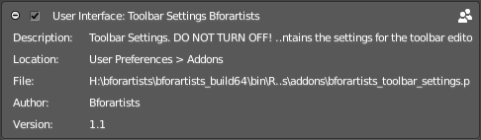
Note: Bforartists comes with some add-ons that are required by Bforartists to work properly. You will see a warning in those addons. Don't turn them off. If off, vital parts of Bforartists will not longer work, ei the toolbar settings.

Search Extensions
You need to have online access granted so that you can see and search the available themes and/or addons.

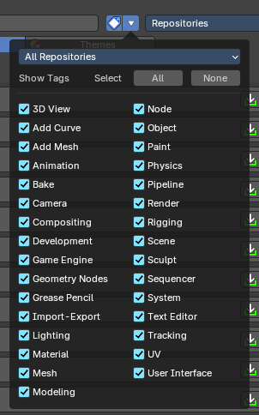
Filter Extensions
Filters the extensions content by tags and repositories. This allows users to filter, organize, and manage extensions and themes based on functional tags.

Filter Extensions Settings Dropdown

Dropdown – Repository Filter
Filters extensions by repository source. Selecting a repository updates the tag list and extension visibility accordingly.

Show Tags
Toggles the visibility of the tag filter list. When enabled, displays all available functional tags as checkboxes or none.

Tag List (Checkboxes)
Each tag corresponds to a functional area in Blender. Checking a tag includes extensions related to that domain.

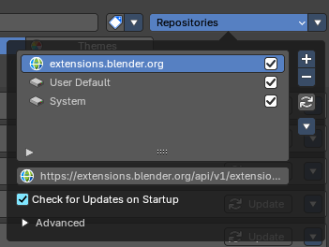
Repositories
Manage the extension repositories.
Extensions are managed in so called repositories. A place where the addons are stored. This includes the online sources, but also where the addons are stored at your local installation.

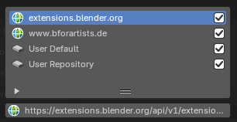
Repository List
The list of currently available repositories.
extensions.blender.org is the official extension repository from Blender, which we rely at. It is online.
User Default is the offline default repository. This includes the core addons and the addons that you have installed.

Enable
Enable the repository.

URL field
In case the selected repository is a online source you will see the URL property to this repository. You can also edit this URL here.

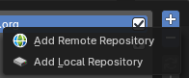
Add
Add a repository.

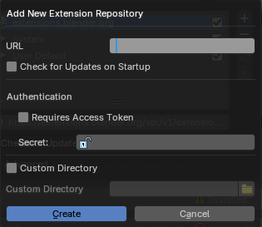
Add Remote Repository
Add a repository from an online source. It should ideally contain extensions. A dialog will pop up.

Add New Extension Repository dialog

URL
The url for the online repository

Check for Updates on Startup
Check if updates are available.

Authentification
For addons that requires an authentification.

Requires Access Token
Enable Requires Access Token.

Secret
The secret password for the authentification.

Custom Directory
Use a custom install directory. By default it installs in \AppData\Roaming\Bforartists\Bforartists\VERSIONNUMBER\scripts\addons
VERSIONNUMBER stands for the Blender version number here.
Note that the custom directory needs still to be in the \AppData\Roaming\Bforartists\Bforartists\VERSIONNUMBER\ path.

Custom Directory
The custom directory that you want to use.

Create
Create the new repository.

Cancel
Cancel.

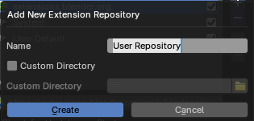
Add Local Repository
Add a local repository.

Name
The name of the repository

Use Custom Directory
Use a custom install directory. By default it installs in \AppData\Roaming\Bforartists\Bforartists\VERSIONNUMBER\scripts\addons
VERSIONNUMBER stands for the Blender version number here.
Note that the custom directory needs still to be in the \AppData\Roaming\Bforartists\Bforartists\VERSIONNUMBER\ path.

Custom Directory
The custom directory that you want to use.

Create
Create the new repository.

Cancel
Cancel.

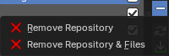
Remove
Remove the chosen repository.

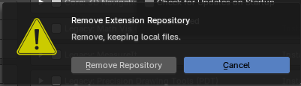
Remove Repository
Removes the repository from the repository list. But keeps the files locally.

Remove Repository & Files
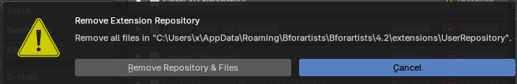
Removes the repository from the repository list. And removes the local files too.

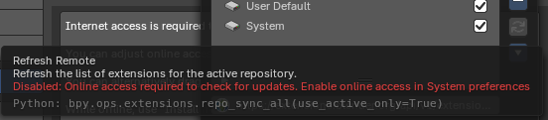
Refresh Remote
Refreshes the content. You must be online to set the menu item to active.

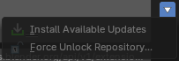
Active Extension Repository
You must be online to set the menu items to active.

Install Available Updates
Install all available updates. Note that this feature requires to allow online access. Also note that this feature works at the selected repository only.

Force Unlock Repository
Remove the repository file-system lock in case it is locked.

Check for Updates on Startup
In case the selected repository is an online source you will see the Check for Updates on Startup properties to this repository.
Checks for available updates. And notifies you about it in the list of extensions then. You can also turn on the Extensions Updates notification in the footer.

Advanced Subpanel
Adjust settings for the repositories.

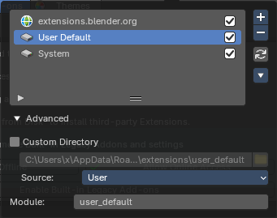
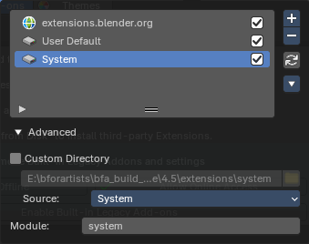
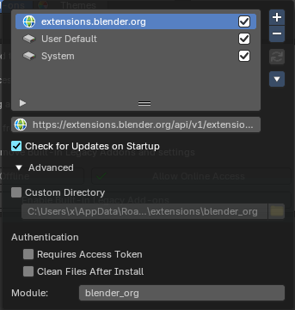

The content differs, dependant of the chosen repository.

Custom Directory
Use a custom install directory. By default it installs in \AppData\Roaming\Bforartists\Bforartists\VERSIONNUMBER\scripts\addons
VERSIONNUMBER stands for the Blender version number here.
Note that the custom directory needs still to be in the \AppData\Roaming\Bforartists\Bforartists\VERSIONNUMBER\ path.

Directory
The custom directory that you want to use.

Browse
Browse for the directoriy that you want to use

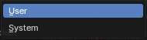
Source
Select if the repository is a system directory, or a user directory. Normally this updates automatically when you use a system or a user directory in the list above. But here you can customize it.

Authentification
For addons that requires an authentification.

Requires Access Token
Enable Requires Access Token.

Secret
The secret password for the authentification.

Module
The unique module identifier. It identifies the repositories.

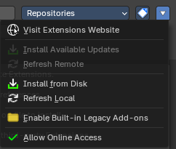
Extensions Settings

Visit extensions website
Opens the Blender extension page in a web browser.

Install Available Updates
Install all available updates. Note that this feature requires to allow online access.

Refresh Remote
Check if updates for extensions are available for the online extensions. Note that this feature requires to allow online access. Also note that this feature works on ALL repositories.

Install from Disk
You can optionally also install addons and extensions from a disk location using the install from disk operators.

Refresh Local
Refresh local extensions to apply changes. Note that this feature works on ALL repositories.

Enable Built-in Legacy Add-ons
Blender does by default just use online add-ons. But Bforartists comes with some add-ons that are vital to run the software. And these offline add-ons must be on so that Bforartists is fully functional.
By Default these add-ons are already enabled. So no action is required. But if you by accident disable a Bforartists core add-on, this is the place to re-enable them all.

Allow Online Access
Allow internet access to download extensions. Bforartists may access configured online extension repositories to download and update. And installed third party extensions may access the internet for their own functionality.

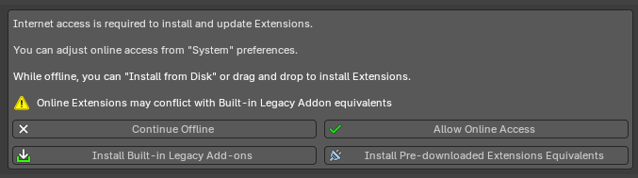
Online Extensions
An explicit dialog suggests that to access Extensions, you must allow internet access. This is so you can download and work with the online Blender extensions repository.
To install extensions from the internet, internet access is required. You can adjust this later from the “System” preferences in the Network panel. Once you have allowed online access, you will access the default Blender extensions website with free addons and themes.

Continue Offline
Closes the dialog. Note that you can always (re) enable the online access from the Extension settings menu.

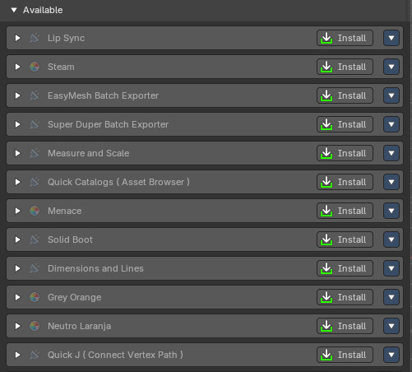
Allow Online Access
Allow Bforartists to access the internet to load and display and also install available online add-ons and themes. You will see a list of all available online extensions then.

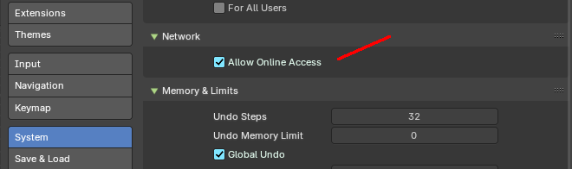
Note: you can change your choice afterwards in the System preferences.
Also that you can also install extensions from disk or drag and drop extensions to install from disk when you are offline.

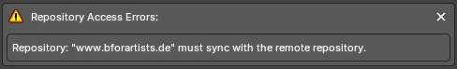
Repository Acccess Errors
In case you have added an invalid online repository you might be faced with a warning. You might want to fix the invalid extension repository then.
Note: Bforartists doesn't host extensions. This URL was just added for demonstration purposes.

Enable/Remove Built-in Legacy Add-ons
Bforartists comes with some core add-ons that are vital to run the software, but this also alternatively ships with legacy Built-In addons. These addons are opt-in and have Extension equivalents also included offline.
Core add-ons must be on so that Bforartists is fully functional. Built-In Legacy addons are optionally provided for complete offline extended usability.

Install Pre-downlaoded Extensions Equivalents
If you have enabled legacy addons, you also have the options to remove and alternatively install the Extensions equivalents while remaining offline. This will copy the extensions to your user settings, and if you want to continue updating them when being online, they will then be available locally with online access to their repository for future updates. This helps to you to migrate your legacy addons to Extensions.

Add-ons

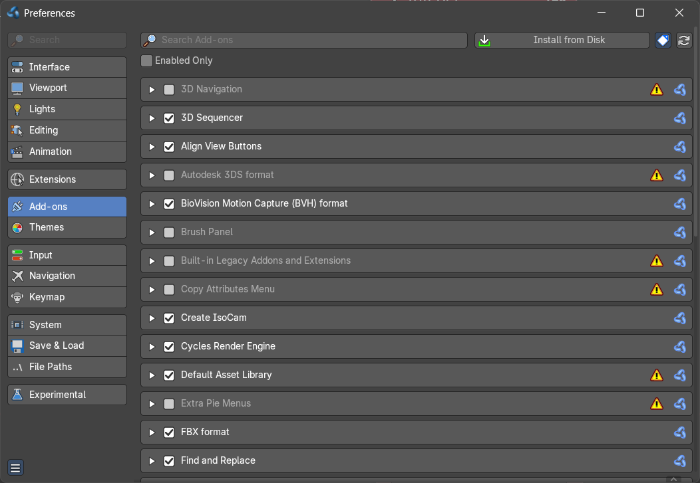
Manage the available addons. Note that for online addons you head over to the Extensions tab, and install it from there. The not installed but available online addons will not show here.

Drag and Drop
One of the methods to install an addon is to drag an extension zip file from the internet or from the computer into Bforartists from the operating system expolorer. This will automatically install and activate the addon or theme extension.

Search field
Search for specific addons.

Enabled only
Just display the enabled addons.

Install from Disk
You can install addons and extensions from a disk location. It will open a file browser where you can locate and load your add-on.

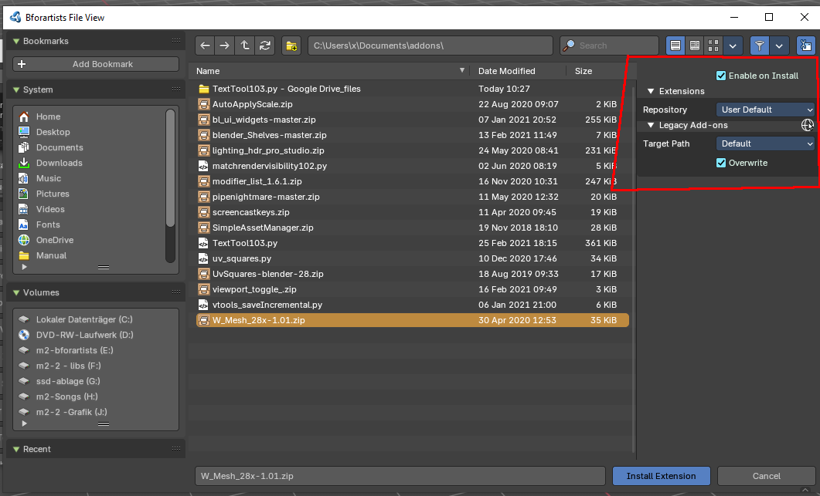

Extension Tags
Filter the content by tags.

Refresh Local
Refresh the local add-ons. Any probems will be reported.

List of Addons
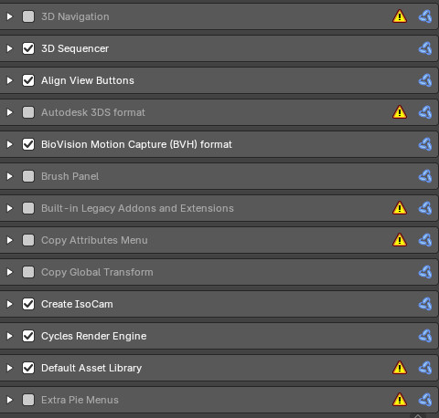
The actual list with the addons.
The addons with the warning sign is no error. It marks the bforartists legacy addons that are built in. But may have a conflict with the online version then.

Themes
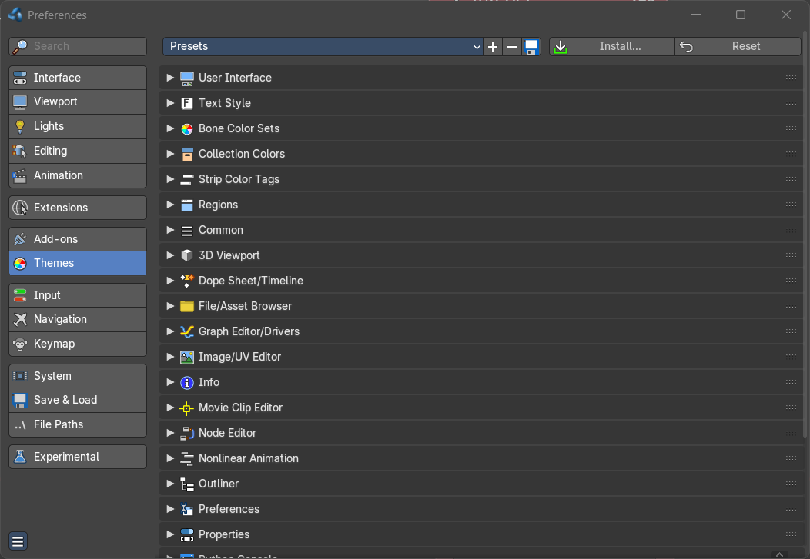
The Themes tab allows you to customize interface appearance and colors. There are various elements that can be themed.
Any change here will appear in real-time on your screen in the corresponding editor.

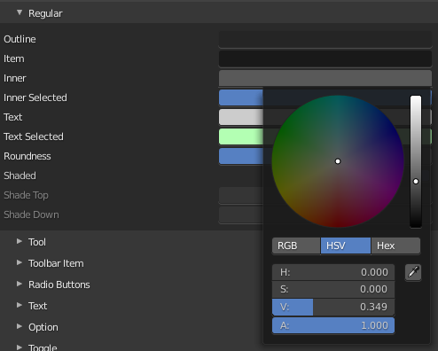
To change a color for a UI element, simply click at one of the color fields. A color dialog will open up to choose a new color.

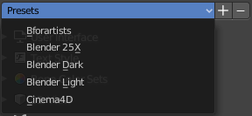
Presets
Bforartists comes with several theme presets. You can choose between them in the drop down box. Don't forget to save the user settings to make the change to the new preset permanent.

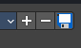
Create new Theme
To create a new theme, click the + button next to the preset selection drop-down and enter a name. This will save the theme to an XML file in the ./scripts/presets/interface_theme/ sub directory of one of the configuration directories.
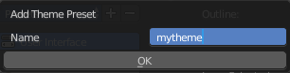
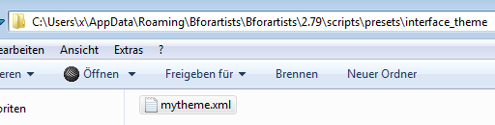
To share the new created theme you have to copy it from that folder. This XML file can then be loaded as a theme at another computer with Bforartists installed.

Remove Theme
To remove a custom theme, click the - button next

Save Theme
To save changes to a custom theme, click on the save icon.

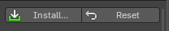
Install
Install an external theme. This button will open a file browser.

Reset
Resets all made changes, and resets the current theme to its initial state.

List of Editors
The list of the editors that you can theme. Every editor can have its own theming.
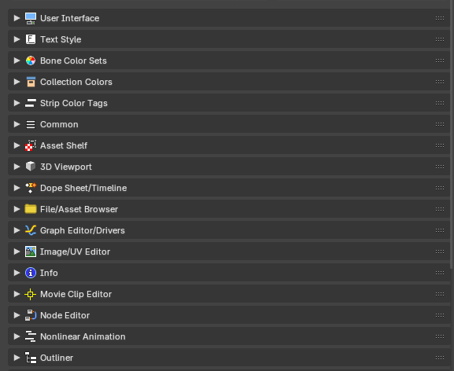

User Interface
Controls the global look of Blender’s UI—buttons, panels, headers, and background colors across all editors.

Text Style
Defines font colors and styles used in labels, tooltips, and text-based editors.

Bone Color Sets
Lets you assign custom colors to bone groups in Pose Mode, useful for rigging and animation clarity.

Collection Colors
Sets colors for collections in the Outliner, helping visually organize scene hierarchies.

Strip Color Tags
Applies tag colors to strips in the Video Sequencer and Nonlinear Animation editors for quick identification.

Regions
Handles the common region areas like Asset Shelves, channels, scrubbing and marker settings and toolbars and sidebars.

Common
Handles shared UI elements like animation and curve settings.

Asset Shelf
Customizes the appearance of the Asset Shelf, including preview thumbnails, labels, and background styling.

3D Viewport
Controls mesh display, overlays, selection highlights, and shading in the main modeling and animation workspace.

Dope Sheet / Timeline
Defines keyframe colors, channel backgrounds, and marker styles for animation timelines.

File / Asset Browser
Sets visual styles for file lists, asset previews, and tag indicators in the browser interface.

Graph Editor / Drivers
Colors for animation curves, handles, and driver indicators—essential for fine-tuning motion.

Image / UV Editor
Controls UV line colors, grid backgrounds, selection highlights, and image overlays.

Info
Styles the header and system log messages, including warnings, errors, and notifications.

Movie Clip Editor
Customizes tracking marker colors, clip overlays, and annotation visuals for motion tracking workflows.

Node Editor
Defines node socket colors, wire styles, backdrop shading, and node selection highlights.

Nonlinear Animation
Sets strip colors, selection highlights, and timeline overlays in the NLA editor for layered animation.

Outliner
Controls tree view colors, selection highlights, and hierarchy lines for scene organization.

Preferences
Applies theme settings to the Preferences window itself, including tabs and panels.

Properties
Styles the Properties editor, which includes modifiers, materials, constraints, and more.

Spreadsheet
Controls cell background, grid lines, and selection colors for data views and attribute inspection.

Text Editor
Defines syntax highlighting, background, cursor, and line number colors for scripting and notes.

Top Bar
Customizes the global top menu bar and tool headers for consistent branding or visibility.

Video Sequencer
Sets strip colors, waveform display, and timeline elements for video editing workflows.

Input
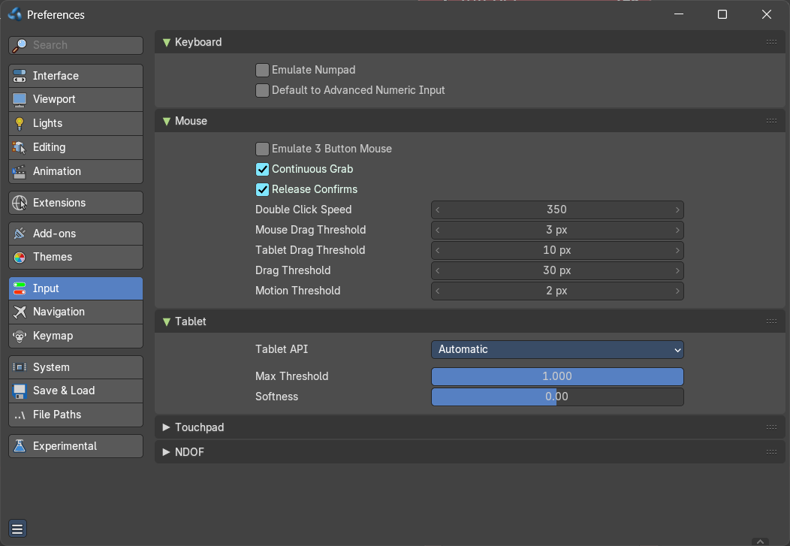
This tab contains some input related settings.

Keyboard

Emulate Numpad
Laptops usually doesn't have Numpad keys. Choose to use the number keys above the letters as Numpad keys.

Default to advanced numeric input
When entering numbers while transforming default to advanced mode for full math expression evaluation.

Mouse

Emulate 3 Button Mouse
In the Windows world 3 button mouses are common. But Apple for example has a single mouse button. Bforartists can emulate a 3 button mouse. The third mouse button will then be emulated by a key combination.
3-button Mouse | 2-button Mouse | Apple Mouse
LMB | LMB | LMB (mouse button)
MMB | Alt-LMB | Alt-LMB (Option/Alt key + mouse button)
RMB | RMB | Cmd-LMB (Command/Apple key + mouse button)

Mouse/Keyboard combinations referenced in this manual can be expressed with the combinations shown in the table. For example, MMB drag becomes Alt-LMB drag. Shift-Alt-RMB becomes Shift-Alt-Cmd-LMB on a single-button mouse.

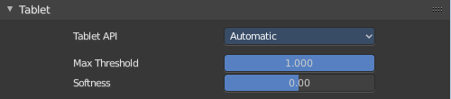
Tablet
This panel contains some tablet related settings.

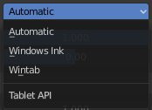
Tablet API
Choose which API Bforartists should choose for the pressure sensitivity of your tablet.

Max Threshold
The raw input pressure value which is interpreted as 100 % by Bforartists.

Softness
Adjust the pressure softness of the low pressure response onset using a gamma curve.

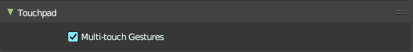
Touchpad

Multi Touch Gestures
Use multi touch gestures for navigation with touchpad instead of scroll wheel emulation.

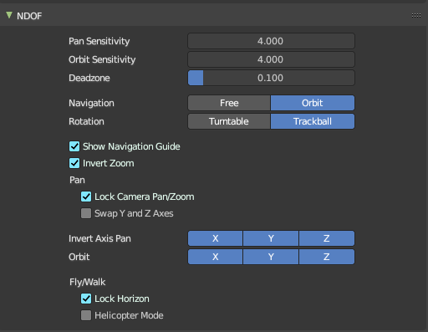
NDOF
You can use a 3D mouse in Bforartists. Here you find some 3D mouse related settings.

Pan Sensitivity
Adjust the pan sensitivity.

Orbit Sensitivity
Adjust the orbit sensitivity

Deadzone
The initial movement that is needed before the movement gets recognized.

Navigation
Choose the navigation style between Free and Orbit.

Rotation
Adjust in what style you rotate the 3D View. Turntable and Trackball navigation reacts a bit different. Turntable navigation tries to hold the horizon line while rotation. Turntable rotation rotates also the horizon line.

Show Navigation Guide
Display the axis and center during rotation.

Invert Zoom
Zoom using opposite direction.

Lock Camera Pan/Zoom
Pan / Zoom the camera view instead of leaving the camera view when orbitting.

Pan Swap Y and X Axes
Pan uses up - down instead of forward - backward

Invert Axis Pan
The invert axis for panning. Inactive axis are not inverted.

Orbit
The axis to orbit around when panning.

Fly / Walk

Lock Horizon
Keep horizon level while flying with 3D mouse.

Helicopter Mode
Using up/down directly controls the Z position in the 3D viewport.

Navigation
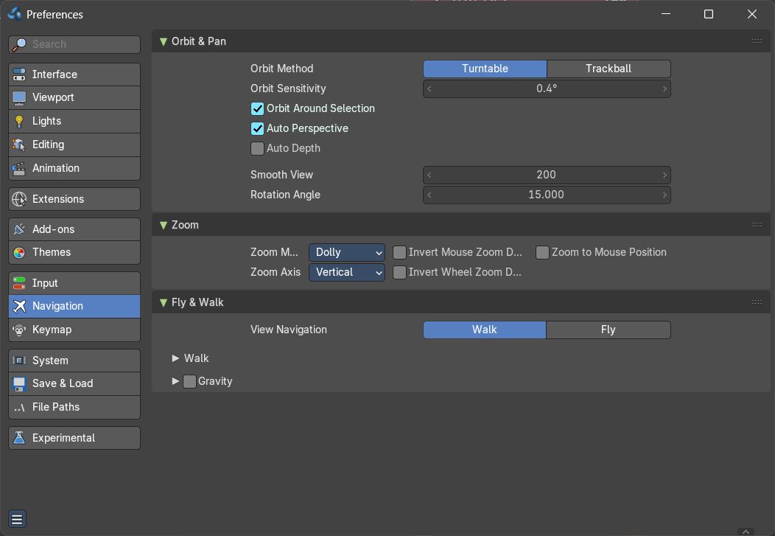
The navigation section contains the settings for navigating in the 3D view.

Orbit & Pan

Orbit Method
Adjust in what style you rotate the 3D View. Turntable and Trackball navigation reacts a bit different. Turntable navigation tries to hold the horizon line while rotation. Turntable rotation rotates also the horizon line.

Orbit around selection
The selected object becomes the rotation center of the viewport. When there is no selection the point of the last selection will be used.

Auto Perspective
With Auto perspective off when you switch to one of the side views, then the chosen orthographic or perspectivic view is kept. Means when you have the distorted perspectivic view, and switch to top view, then your mesh will be perspectivic distorted here too.
With Auto Perspective the view in the side views will be orthographic, and not perspectivic, no matter what View Persp/Ortho is chosen.

Auto Depth
Use the depth under the mouse to improve view pan, rotate, zoom functionality.

Smooth View
The switch to change to another view is animated. Adjust the length of time the animation takes when changing the view with the Numpad (Top/Side/Front/Camera...). A value of zero will remove the animation, and immediately switch to the chosen view.

Rotation Angle
Rotation step size in degrees, when Numpad4, Numpad6, Numpad8, or Numpad2 are used to rotate the 3D View.

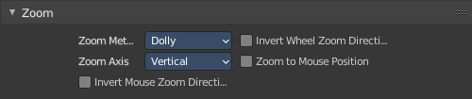
Zoom

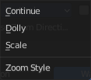
Zoom Method
Adjust the zoom style.

Continue
The Continue zooming option allows you to control the speed (and not the value) of zooming by moving away from the initial click point. Moving up from the initial click-point or to the right will zoom out, moving down or to the left will zoom in. The further away you move, the faster the zoom movement will be.

Dolly
Dolly zooming works similarly to Continue zooming except that zoom speed is constant.

Scale
Scale zooming depends on where you first click in the view.

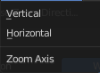
Zoom Axis
With Vertical moving up zooms out and moving down zooms in. With Horizontal moving left zooms in and moving right zooms out.

Invert Mouse Zoom Direction
Inverts the Zoom direction for Dolly and Continue zooming.

Invert Wheel Zoom Direction
Inverts the direction of the mouse wheel zoom.

Zoom to Mouse Position
When enabled, the mouse pointer position becomes the focus point of zooming instead of the 2D window center.

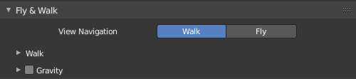
Fly & Walk
Fly and walk are special navigation modes. They can be found in the Navi menu. The Fly & walk section also contains some settings from the View navigation style, since this style uses elements from walk and fly navigation too.

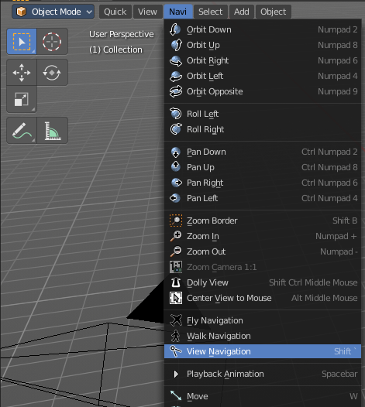
View Navigation
Adjust how the View navigation in the 3D view behaves. You can choose between walk and fly.

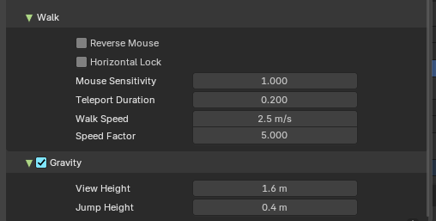
Walk

Reverse Mouse
Reverse the mouse movement when you move upwards or downwards

Horizontal Lock
Locks horizontal movement in Walk Mode, keeping the viewpoint level and aligned with the ground. This ensures stable navigation within scenes, preventing any vertical shifts and maintaining a consistent horizontal plane.
This is a Bforartists exclusive feature.

Mouse Sensitivity
Adjust how strong the viewport movement reacts to the mouse movement

Teleport Duration
Adjust the teleport duration when teleporting in navigation mode.

Walk Speed
Adjust the walk speed

Speed Factor
Adjust the run speed.

Gravity
Choose if the virtual character, your point of view, uses gravity.

View Height
Adjust the height of the point of view for your virtual character. This setting requires to have Gravity on.

Jump Height
Adjust the maximal jump height for your virtual character. This setting requires to have Gravity on.

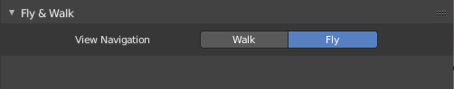
Fly
Fly has no further settings.

Keymap
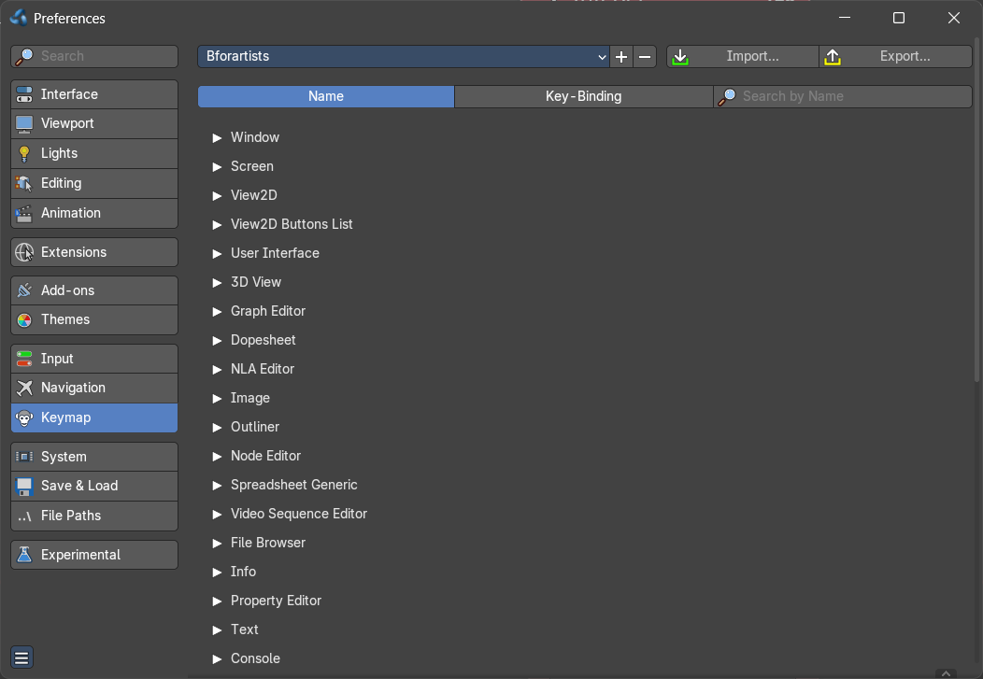
The key map allows you to customize how Bforartists reacts to mouse and keyboard, and change key map entries. All Input behavior is defined in the key map.

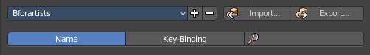
Header

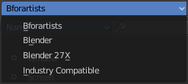
Key Configs
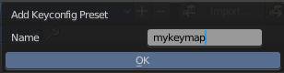
A drop down menu to choose existing key maps. The + button at the right adds a new key map. The current configuration will then be saved as a new key map.

Import
Import an external key map. This opens up a file selector to choose the python file.

Export
Export a key configuration python file from Bforartists.

Filter Type
Define if you want to search for a tool name or for a hotkey. By tool name, or by the hotkey name

Search Field
Enter a search string.

Key map Editor
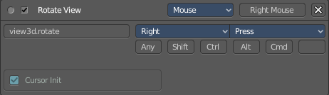
The Key map editor is the list where the single inputs are defined. Every input can have several specific operator settings in the lower area. The upper area defines the general things like the key combos. The lower area those operator specific settings.
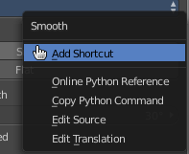
Normally you don't edit those key entries manually. Most of the usual tools have an entry in the right click menu to create or to change the hotkey. But sometimes you have to do this task manually.

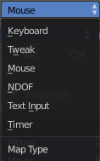
Map Type
Here you define what input will control the function.

Type of Event
Here you define your main hotkey. In our case the right mouse.

Operator
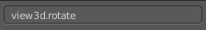
The Python operator name for the tool.

Type of Event
The main hotkey again. For special events like mouse events you have a drop down box here.

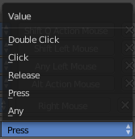
Value
What key action is required. On click, on double click, etc. ...

Secondary hotkeys
Many hotkeys uses a key combination, for example Shift D for select. Define those secondary hotkeys.

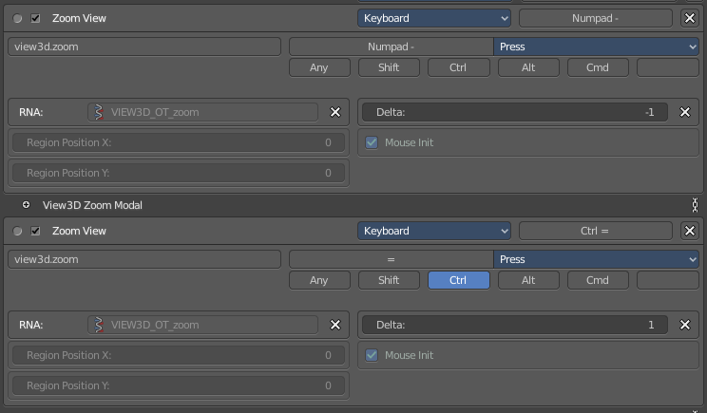
Specific settings
Every operator can have several settings. And some tools even just defines itself by those different settings. Here you can see two different zoom view operators. They just differ in the Delta value.
What is equal in the key map in all cases is the RNA entry. That's the name of the operator again. But this time not the Python code operator name. But the C code operator name.

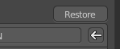
Restore
When you modify a key map item, then you will see a Restore button appear at the right side. This indicates that this key map item got modified. A click at the Restore button will restore the original hotkey.

System
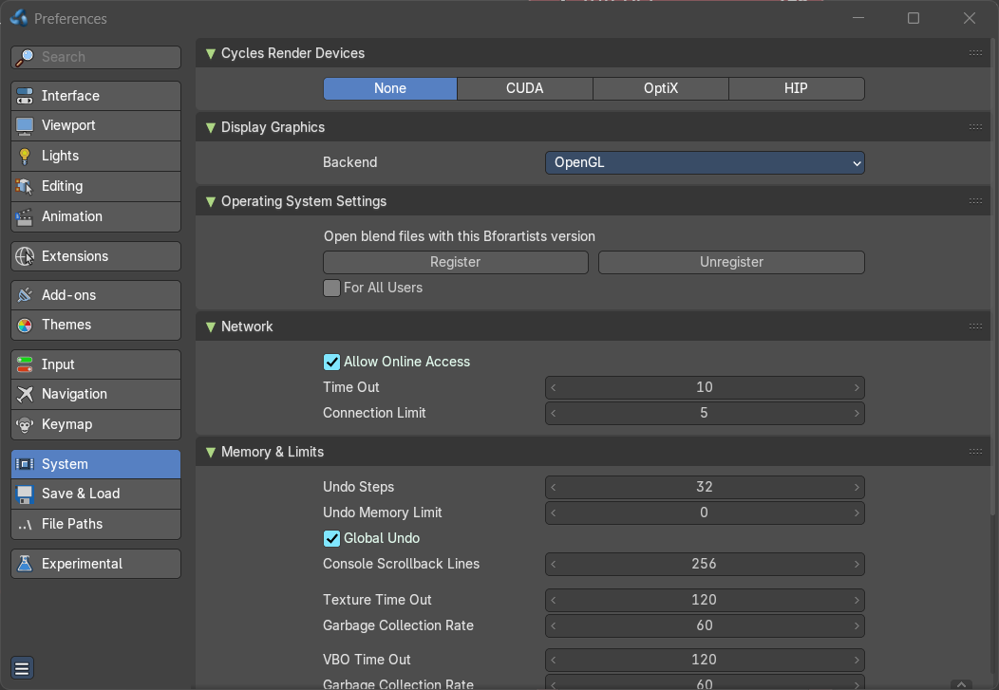
The system tab contains system relevant settings. Such as Cuda for Cycles renderer or OpenCL or Memory related settings.

Cycles Render Devices
The Options here will set the compute device used by the Cycles render engine.

None
When set to None or the only option is None: your CPU will be used as a computing device for Cycles Render Engine.

CUDA
If the system has a compatible Nvidia CUDA enabled graphics card you will be able to use it to render with the Cycles render engine.

OptiX
Optix is a raytracing framework from Nvidia that runs on the GPU.

HIP
If the system has a compatible HIP device, it will show up has an option for rendering cycles.

OneAPI
If the system has a compatible oneAPI device, it will show up has an option for rendering cycles.

Metal (Mac-OS only)
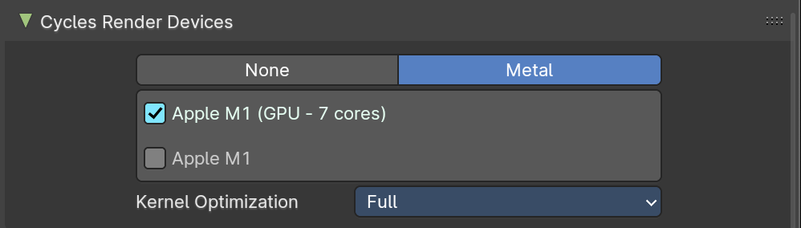
If the system has a M1/M2 chip, users can use the Metal back-end for rendering in cycles.

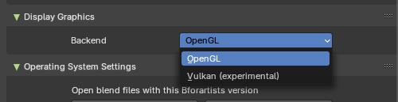
Display Graphics

Backend
This setting is which display graphics will be used in the viewport.
Note: Changing this will require restarting Bforaritsts.

OpenGL
Use the OpenGL backend.

Vulkan (Experimental)
Use the Vulkan backend. Bare in mind this is experimental.

Operating System Settings
Windows only.
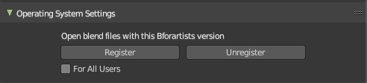
Register or unregister to connect the blend file with this Bforartists version.

For all Users
Register the file association for all users, or just for the current user.

Make default
Associates the .blend file with this installation of Bforartists. This means that double clicking at a .blend file will now open this file with the currently open Bforartists installation. This is useful when you work with different versions of Bforartists, and want to open the files with an older or newer version.

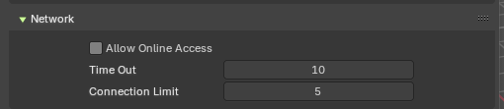
Network
Allow or disallow Online Access.
Online access is required to install extensions from external online repositories, and to update them.

Allow Online Access
Allow internet access. Bforartists may access configured online extension repositories. Installed third party add-ons may access the internet for their own functionality.

Time Out
The time in seconds to wait for online operattions before a connection may fail with a time-out error. Zero uses the system defaults.

Connection Limit
Limit the number of simultaneous internet connections online operations may make at once. Zero disables the limit.

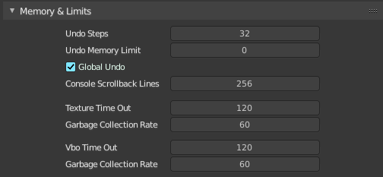
Memory and Limits

Undo Steps
Number of Undo steps available.

Undo Memory Limit
Maximum memory usage in Mb (0 is unlimited).

Global Undo
Bforartists Undo system is split in several subpart. Global undo stores the undo step outside of Edit mode. For example for duplicating Objects, changing panel settings or switching between modes.

Console Scrollback Lines
Maximum number of lines to store for the console buffer.

Texture Time Out
Time since last access of a GL texture in seconds, after which it is freed. Set to 0 to keep textures allocated. Minimum: 0, Maximum: 3600.

Garbage Collection Rate
Number of seconds between each run of the GL texture garbage collector. Minimum: 0, Maximum: 3600.

VBO Time Out
Time since last access of a GL Vertex buffer object, in short VBO, in seconds after which it is freed. Set to 0 to keep VBO allocated.

Garbage Collection Rate
Number of seconds between each run of the GL vertex buffer garbage collector. Minimum: 0, Maximum: 3600.

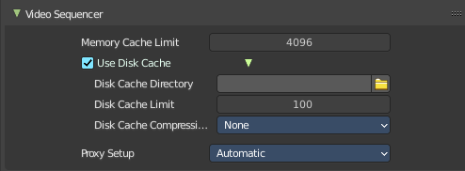
Video Sequencer

Memory Cache Limit
Upper limit of the sequence's memory cache (megabytes). For optimum clip editor and sequencer performance, high values are recommended.

Use Disk Cache
Store cached images to disk.

Directory
The disk cache directory.

Cache Limit
The disk cache limit in gigabytes.

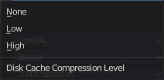
Compression
What compression method to use. Note that compression saves space, but costs performance.

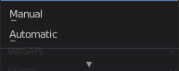
Proxy Setup
Proxies are preview objects, reduced in size to make a smooth working possible. Images for example.

Automatic
Automatically create proxies for each image material.

Manual
You have to create the proxies by hand.

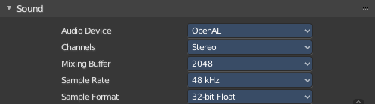
Sound

Audio Device
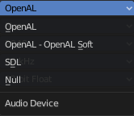
Set the audio device.

OpenAL
Provides buffered sound rendering with 3D/spatial support.

OpenAL - OpenAL Soft
Provides buffered sound rendering with 3D/spatial support.

SDL
Uses Simple Direct Media Layer API from libsdl.org to render sounds directly to the sound device output.

Null
No Audio support. No audio output, but audio strips can be loaded normally.

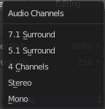
Channels
Set the audio channel count. Available options are: Mono, Stereo, 4 Channels , 5.1 Surround , 7.1 Surround

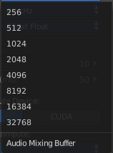
Mixing Buffer
Set the number of samples used by the audio mixing buffer. Available options are: 512 , 1024 , 2048, 4096 , 8192, 16384, and 32768

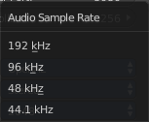
Sample Rate
Set the audio sample rate. Available options are: 44.1 Khz, 48 Khs, 96 Khz and 192Khz

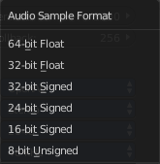
Sample Format
Set the audio sample format. Available options are: 32 bit float, 8 bit Unsigned, 16 Bits Signed, 24 Bits Signed, 32 Bits Signed, 32 Bits Float, and 64 Bits Float.

Save & Load

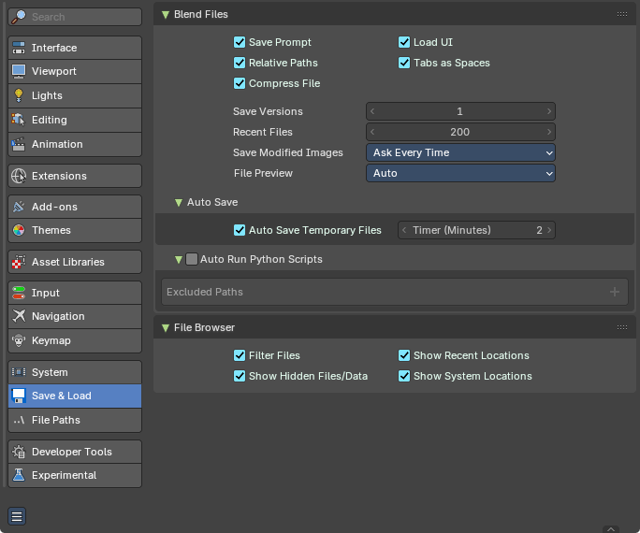
Blend Files
Blend file related settings. What happens at load, what happens at save …

Save Prompt
Ask for confirmation when quitting with unsaved changes.

Relative Paths
By default, external files use a relative path.

Compress File
Compress blend-file when saving.
The option to Compress files will compact your files whenever Blender is saving them. Dense meshes, large packed textures or lots of elements in your scene will result in a large blend being created.
This option may slow down Blender when you quit, or under normal operation when Blender is saving your backup files. Using this option traces processor time for file-size.

Load UI
In Bforartists you can load the scene in the screen layout in which you have saved it. Default is off.
This can also be changed individually when loading a file from the Open blend-file panel of the File Browser.

Tabs as Spaces
For text files, automatically convert tabs into spaces when loading a blend file that contains a text file. Correct indentation is relevant for python scripts.

Save Versions
Number of versions created for the same file (for backup).
This option tells Bforartists to keep the indicated number of saved versions of your file in your current working directory when you manually save a file. These files will have the extension: .blend1, .blend2, etc., with the number increasing to the number of versions you specify. Older files will be named with a higher number. e.g. With the default setting of 2, you will have three versions of your file: *.blend (your last save), *.blend1 (your second last save) and *.blend2 (your third last save).

Recent Files
The number of recent files to display in the Recent panel.

Save Modified Images

Ask Every Time
Show dialog to save modified images when saving the .blend file.

Always Save
Always save modified images when saving the .blend file.

Never Save
Never save modified images when saving the .blend file.

File Preview

None
When this option is off, previews of images and materials in the File Browser are created on demand.

Auto
Automatically create previews of images and materials in the File Browser. The best preview type is chosen automatically.

Screenshot
Capture the entire window to create previews of images and materials in the File Browser.

Camera Preview
Use a workbench render to create the previews of images and materials in the File Browser.

Auto Save

Auto Save Temporary File
Enable Auto Save. Auto save creates a temporary file.
Checking this box tells Blender to automatically save a backup copy of your work-in-progress to the Temp directory (refer to the File tab in the Preferences for its location).
The Auto Saved files are named using a random number and have a blend extension.

Timer
Adjust the number of minutes between each Auto Save. The minimum is 1, and the Maximum is 60 (Save at every one hour).

Auto Run Python Scripts
Run the python scripts at loading a blend file that includes these scripts.

Excluded paths
Define file paths where loaded blend files should not run the included scripts even when auto run python scripts is ticked.

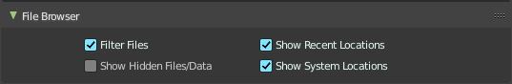
File Browser
File browser related settings.

Filter Files
By activating this, the file dialog in the File Browser will only show appropriate files in the Load dialog. Blend files for example.
The selection of file types can also be changed in the header of the file dialog.

Show Hidden File/Data
On non Windows systems like Linux and Mac OS X files are hidden by a dot in front of the file name. Here you can make them visible in the file browser if you want. Note that this feature does not work with Windows.

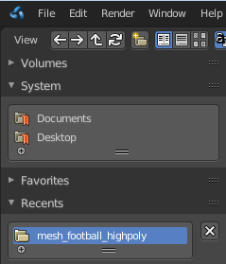
Show Recent Locations
Hides the Recent panel of the File Browser which displays recently accessed folders.

Show System Bookmarks
Hides the System Bookmarks panel of the File Browser which displays the system bookmarks.

File Paths
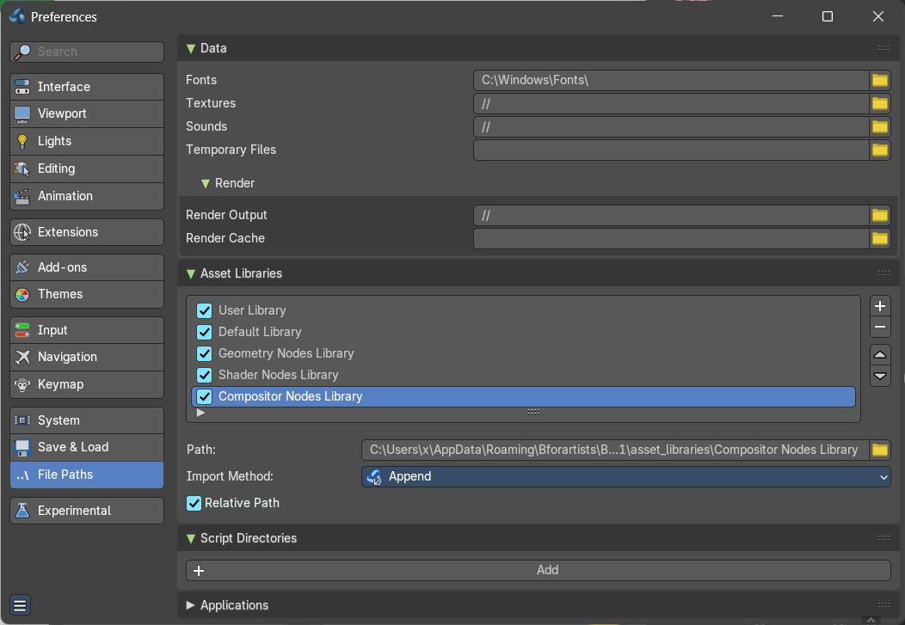
Contains everything file path related.

Data

Fonts
Default location when searching for font files.

Textures
Default location when searching for image textures.

Sounds
Default location when searching for sound files.

Temporary Files
The location where temporary files are stored.

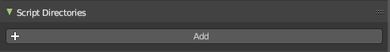
Script Directories
An additional location to search for Python scripts.
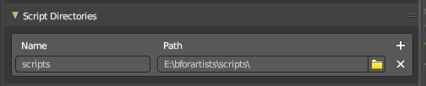
By default Bforartists looks in several directories (OS dependent) for scripts. Here you can add another directory to check for scripts. This can be used to store certain scripts/templates/presets independently of the currently used Blender Version.
Inside the specified folder specific folders have to be created to tell Bforartists what to look for where. This folder structure has to mirror the structure of the scripts folder found in the installation directory of :
- scripts
- add-ons
- modules
- presets
- camera
- cloth
- interface_theme
- operator
- render
- ...
- startup
- templates
Not all of the folders have to be present.
Python scripts (including driver expressions) are not executed by default for security reasons.

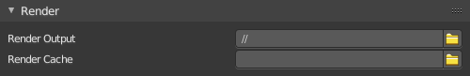
Render

Render Output
Where rendered images/videos are saved.

Render Cache
The location where cached render images are stored.

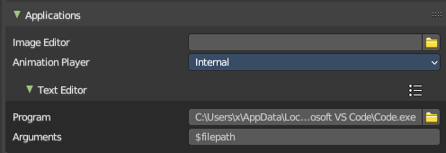
Applications

Image Editor
The path to an external image editing software to use for image editing. Photoshop, Gimp, etc.

Animation Player
By default Bforartists uses the internal player to play back animations. Choose an external program to use for playback of rendered animations. There are also some presets available.

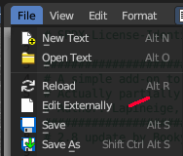
Text Editor
Here you can define an external text editor. Which allows you to edit text files externally. Which then can be done from the File menu in the text editor.

Program
Enter the path to the external text editor.

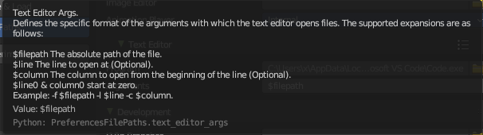
Arguments
Enter at least a filepath argument so that the code can be opened by the external editor. More arguments can be found in the tooltip.

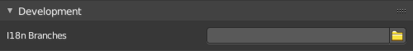
Development

I18n Branches
The path to the /branches directory in your local repository translation copy. This allows translating the UI. See interface tab, the translation panel.

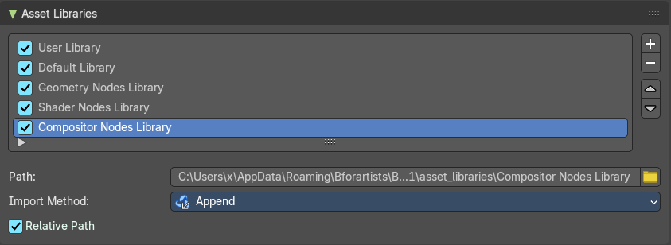
Asset Libraries
The default paths for custom asset libraries. The functionality should be self explaining.
To change the path simply type in a path, or use the path picker at the end.
To add a new path to an asset library click at the + button below the list.
To remove a path click at the X button at the end.

Asset List
The list of available asset libraries. You can deactivate and activate single libraries.

Add
Add a new asset library to the asset list.

Remove
Remove the selected library from the asset list.

Move Up/Down
Move the selected library up or down the list.

Path
The path to the current selected asset library.

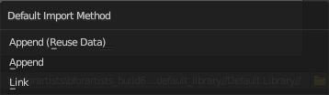
Import Method
How to import the assets from the asset library into the scene.

Append (Reuse Data)
Imports the assets as a copied data. The data is fully imported, and not linked to the asset library. This method reuses existing materials or meshes.

Append
Imports the assets as a copied data. The data is fully imported, and not linked to the asset library. This method also imports every material and mesh from scratch, and can create duplicated redundant data.

Link
Links the assets to the assets in the asset library. The data is linked to the asset library. When you remove the asset library then the linked data is also removed.

Relative Path
Use relative paths when linking from this library.

Developer Tools
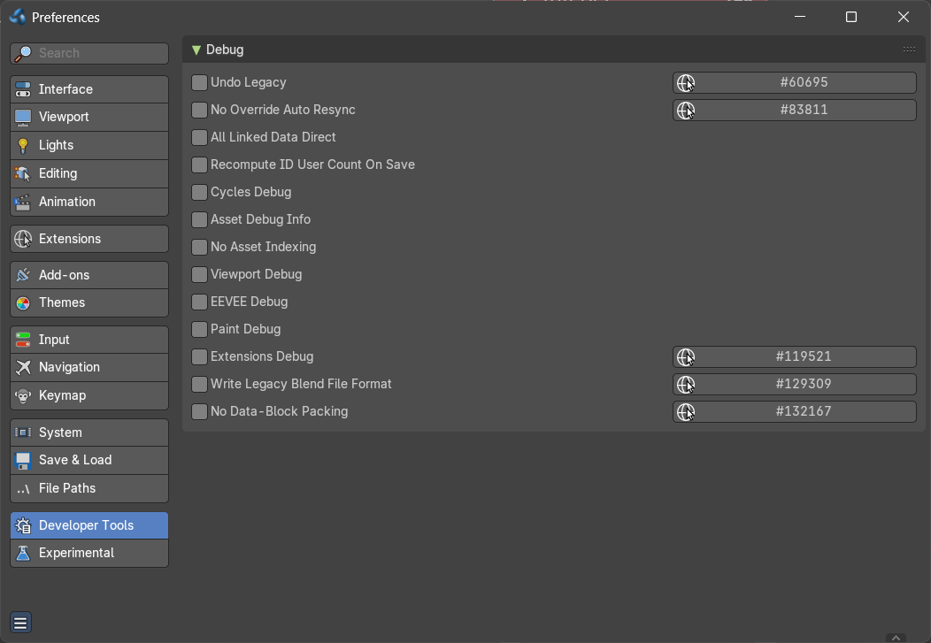
This section contains special debug features, which you can turn on or off here.
This panel just shows when you turn on the Developer Extras in the Interface tab.

Experimental
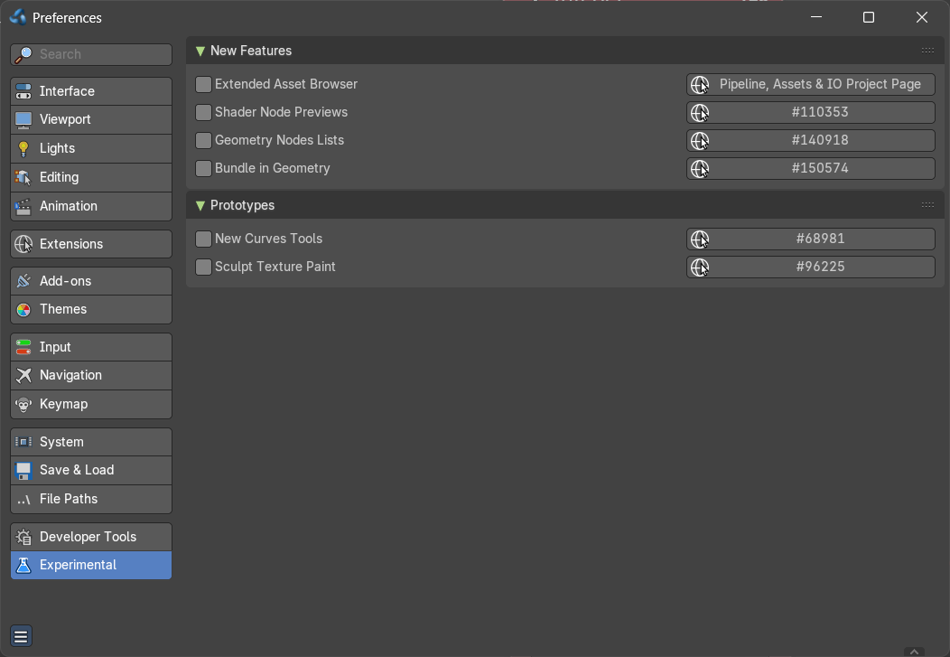
Here you may find some experimental settings from the Blender development. We will not cover them here. They change very quick. Use at own risk!

